Chapter 1: Playing the Game

**ANTONIO JOSÉ MANZANEDO**[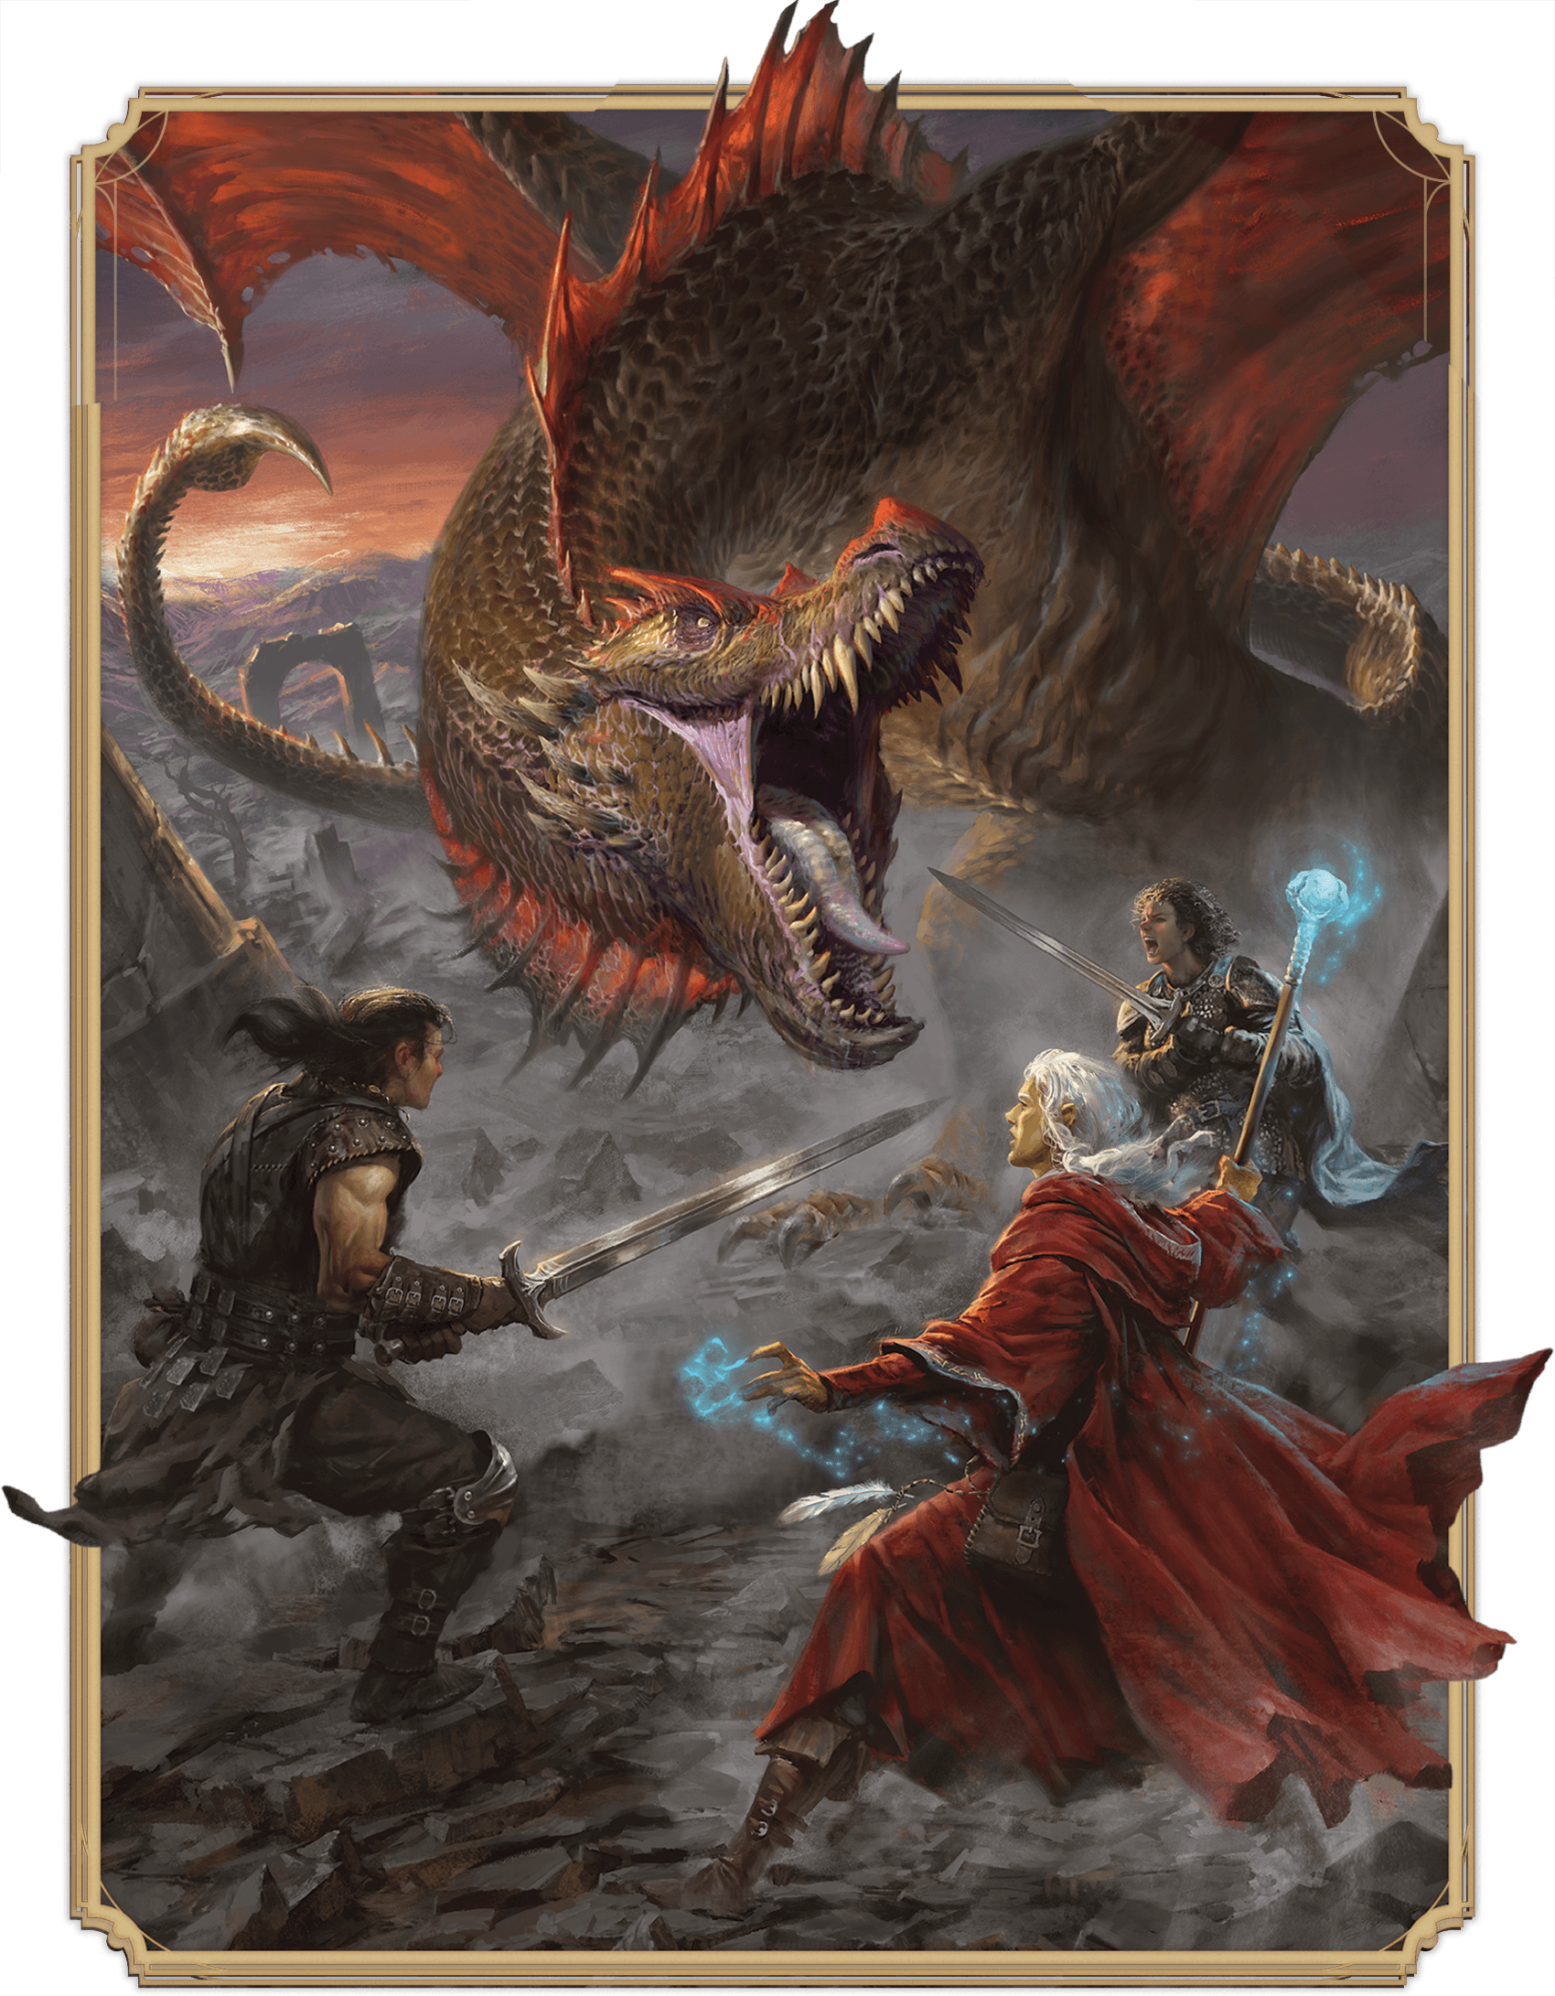](https://media.dndbeyond.com/compendium-images/phb/MKDHZ1nxSXDDLOw2/01-013.opening-art.png)While adventuring in the Dragonlance setting, the siblings Caramon  
Majere, Raistlin Majere, and Kitiara uth Matar provoke the rage of a wyvern

Imagination is a key ingredient of Dungeons & Dragons, a cooperative game in which the characters that you roleplay embark on adventures together in fantasy worlds filled with monsters and magic.

In D&D, the action takes place in the imaginations of the players, and it’s narrated by everyone together. Here’s a glimpse at what that looks like:

**Jared (as Dungeon Master):** After your long journey, Castle Ravenloft towers before you. Crumbling towers of stone—perhaps abandoned guardhouses—loom over the approach. Beyond them, you see a gaping chasm disappearing into deep fog below. A lowered drawbridge spans the chasm, its chains creaking in the wind. Stone gargoyles stare down at you from the high walls, and a pale light spills into the courtyard from the open castle doors beyond.

**Phillip (as Gareth):** I examine the gargoyles. I have a feeling they’re not just statues!

**Maeve (as Mirabella):** I want to see how sturdy the drawbridge is. Do I think we can cross it, or is it going to collapse under our weight?

**Jared:** All right, one at a time. Phillip, Gareth’s looking at the gargoyles?

**Phillip:** Yeah. Is there any hint they might be creatures and not just decorations?

**Jared:** Make an Intelligence check.

**Phillip:** Does my Investigation skill apply?

**Jared:** Sure!

**Phillip (rolling a d20):** Ugh. Seven.

**Jared:** They look like decorations to you. And Maeve, Mirabella is examining the drawbridge?

The adventure continues from there, relying on the DM’s descriptions to set the scenes. Later in the chapter, other examples of play focus on certain aspects of D&D play: [social interaction](https://www.dndbeyond.com/sources/dnd/phb-2024/playing-the-game#SocialInteractionExample), [exploration](https://www.dndbeyond.com/sources/dnd/phb-2024/playing-the-game#ExplorationExample), and [combat](https://www.dndbeyond.com/sources/dnd/phb-2024/playing-the-game#CombatandDamageExample).

**Rules Glossary**

If you read a rules term in this book and want to know its definition, consult the rules glossary, which is [appendix C](https://www.dndbeyond.com/sources/dnd/phb-2024/rules-glossary). This chapter provides an overview of how to play D&D and focuses on the big picture. Many places in this chapter reference that glossary.

Player or DM?

To play D&D, you need one person to be the Dungeon Master and other players (three to six are best) to play adventurers. Which role is right for you?

Being a Player

If you want to be one of the protagonists in your group’s adventures, consider being a player. Here’s what players do:

**Make a Character.** Your character is your alter ego in the fantasy world of the game. After you read this chapter, use the rules in [chapter 2](https://www.dndbeyond.com/sources/dnd/phb-2024/creating-a-character) to create your character.

**Team Up.** Your character joins the other players’ characters to form an adventuring party. These adventurers are allies who face challenges and fantastical situations together. Each character brings distinctive capabilities, which ideally complement those of the other characters.

**Venture Forth.** Your character’s group explores locations and events presented by the DM. You can respond to them in any way you can imagine, guided by the rules in this book. Although the DM controls all the monsters you encounter, the DM isn’t your adversary. The DM guides your party’s journey as your characters become more powerful.

Being the Dungeon Master

If you want to be the mastermind of the game, consider being the DM. Here’s what DMs do:

**Build Adventures.** You prepare the adventures that the players experience. In the [*Dungeon Master’s Guide*](https://www.dndbeyond.com/sources/dnd/dmg-2024), you’ll find advice for how to [create adventures](https://www.dndbeyond.com/sources/dnd/dmg-2024/creating-adventures) and even [createwhole worlds](https://www.dndbeyond.com/sources/dnd/dmg-2024/creating-campaigns#CreatingYourOwnSetting).

**Guide the Story.** You narrate much of the action during play, describing locations and creatures that the adventurers face. The players decide what their characters do as they navigate hazards and choose what to explore. Then you use a combination of imagination and the game’s rules to determine the results of the adventurers’ decisions.

**Adjudicate the Rules.** You oversee how the group uses the game’s rules, making sure the rules serve the group’s fun. You’ll want to read the rest of this chapter to understand those rules, and you’ll find the [rules glossary](https://www.dndbeyond.com/sources/dnd/phb-2024/rules-glossary) essential.

Rhythm of Play

The three main pillars of D&D play are [social interaction](https://www.dndbeyond.com/sources/dnd/phb-2024/playing-the-game#SocialInteraction), [exploration](https://www.dndbeyond.com/sources/dnd/phb-2024/playing-the-game#Exploration), and [combat](https://www.dndbeyond.com/sources/dnd/phb-2024/playing-the-game#Combat). Whichever one you’re experiencing, the game unfolds according to this basic pattern:

1. **The Dungeon Master Describes a Scene.** The DM tells the players where their adventurers are and what’s around them (how many doors lead out of a room, what’s on a table, and so on).
2. **The Players Describe What Their Characters Do.** Typically, the characters stick together as they travel through a dungeon or another environment. Sometimes different adventurers do different things: one adventurer might search a treasure chest while a second examines a mysterious symbol engraved on a wall and a third keeps watch for monsters. Outside combat, the DM ensures that every character has a chance to act and decides how to resolve their activity. In combat, the characters take turns.
3. **The DM Narrates the Results of the Adventurers’ Actions.** Sometimes resolving a task is easy. If an adventurer walks across a room and tries to open a door, the DM might say the door opens and describe what lies beyond. But the door might be locked, the floor might hide a trap, or some other circumstance might make it challenging for an adventurer to complete a task. In those cases, the DM might ask the player to roll a die to help determine what happens. Describing the results often leads to another decision point, which brings the game back to step 1.

This pattern holds during every game session (each time you sit down to play D&D), whether the adventurers are talking to a noble, exploring a ruin, or fighting a dragon. In certain situations—particularly combat—the action is more structured, and everyone takes turns.

**Exceptions Supersede General Rules**

General rules govern each part of the game. For example, the combat rules tell you that melee attacks use Strength and ranged attacks use Dexterity. That’s a general rule, and a general rule is in effect as long as something in the game doesn’t explicitly say otherwise.

The game also includes elements—class features, feats, weapon properties, spells, magic items, monster abilities, and the like—that sometimes contradict a general rule. When an exception and a general rule disagree, the exception wins. For example, if a feature says you can make melee attacks using your Charisma, you can do so, even though that statement disagrees with the general rule.

An Ongoing Game

Sometimes a session of D&D is a complete game in itself (often called a “one-shot”), where you play a short adventure that lasts for just one session. More often, though, D&D sessions are connected in a longer adventure that takes several sessions to complete, and adventures can be strung together into a larger narrative called a campaign.

A campaign is like a TV series, while an adventure is like a season of the series. And a game session is like a single episode—it might be self-contained, but it usually links to the larger plot if there is one.

Adventures

An adventure might be created by the Dungeon Master or purchased (the examples of play in this chapter are inspired by a published adventure, [*Curse of Strahd*](https://www.dndbeyond.com/sources/dnd/cos)). In either case, an adventure features a fantastic setting, such as an underground dungeon, a wondrous wilderness, or a magic-filled city. It includes a cast of nonplayer characters controlled by the DM. Often one of the NPCs is a villain whose agenda drives much of an adventure’s action.

During an adventure, the adventurers explore environments, events, and creatures presented by the DM. Battles, traps, negotiations, mysteries, and more arise during these explorations.

Adventures vary in length and complexity. A short adventure might present only a few challenges and take only one session to complete. A long adventure might involve many combats, interactions, and other challenges and take dozens of sessions.

Campaigns

A campaign is a series of adventures with a consistent group of adventurers following the narrative.

Some campaigns are episodic, where each adventure is its own tale and not much besides the player characters links it to the next one. Other campaigns involve long-running plots, a cast of recurring NPCs, and themes that span multiple adventures, leading toward a climactic conclusion.

As with adventures, a DM might create a campaign from scratch, assemble a campaign from published adventures, or mix homemade material with published material. And the campaign might take place in a world of the DM’s creation or in a published campaign setting, such as the Forgotten Realms or Greyhawk (the latter is described in the [*Dungeon Master’s Guide*](https://www.dndbeyond.com/sources/dnd/dmg-2024)).

Dice

Dice add randomness to the game. They help determine whether characters and monsters are successful at the things they attempt.

**ALEJANDRO PACHECO**[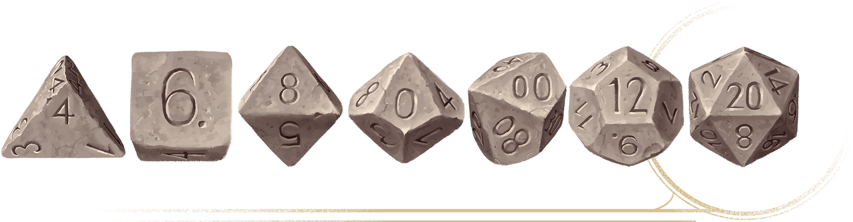](https://media.dndbeyond.com/compendium-images/phb/MKDHZ1nxSXDDLOw2/01-002.dice.png)From left to right: D4, D6, D8, D10 (ones digit), D10 (tens digit), D12, D20

**Round Down**

Whenever you divide or multiply a number in the game, round down if you end up with a fraction, even if the fraction is one-half or greater. Some rules make an exception and tell you to round up.

Dice Notation

The dice used in D&D are referred to by the letter *d* followed by the die’s number of sides: d4, d6, d8, d10, d12, and d20. For instance, a d6 is a six-sided die (the cube that many games use). The illustration on this page shows what each die looks like.

When you need to roll dice, the rules tell you how many dice to roll of a certain type, along with any numbers to add or subtract. For example, “3d8 + 5” means you roll three eight-sided dice, add them together, and add 5 to the total.

**Percentile Dice**

The rules sometimes refer to a d100. While such dice exist, the common way to roll 1d100 uses a pair of ten-sided dice numbered from 0 to 9, known as percentile dice. One die—that you designate before rolling—gives the tens digit, and the other gives the ones digit. If you roll a 7 for the tens digit and a 1 for the ones digit, for example, the number rolled is 71. Two 0s represent 100.

Some ten-sided dice are numbered in tens (00, 10, 20, and so on), making it easier to distinguish the tens digit from the ones digit. In this case, a roll of 70 and 1 is 71, and 00 and 0 is 100.

**D3**

The same *d* notation appears in the expression “1d3,” even though it’s rare to find dice with only three sides. To simulate rolling 1d3, roll 1d6 and divide the number rolled by 2 (round up).

What Are Dice For?

Here are the most common uses of dice in D&D.

**D20 Test**

The 20-sided die (d20) is the most important die you’ll use in the game. It’s central to the core mechanic—called D20 Tests—the game uses to determine whether creatures succeed or fail at the things they attempt during the game (see “[D20 Tests](https://www.dndbeyond.com/sources/dnd/phb-2024/playing-the-game#D20Tests)” later in this chapter). You roll a d20 whenever your character tries to do something that the DM decides has a chance of both success and failure. The higher your roll, the more likely it is that you succeed.

**Damage**

The most common use for dice other than the d20 is to determine damage. When you make a successful attack roll (one kind of [**D20 Test**](https://www.dndbeyond.com/sources/dnd/free-rules/rules-glossary#D20Test)), you roll damage to see how effective the attack is. When you cast a spell, you might also roll damage. Different weapons and spells use different dice for damage. For example, a [**Dagger**](https://www.dndbeyond.com/equipment/3-dagger) uses 1d4, a [**Greataxe**](https://www.dndbeyond.com/equipment/21-greataxe) uses 1d12, and a [***Fireball***](https://www.dndbeyond.com/spells/2618887-fireball) spell uses 8d6.

**Random Tables**

Occasionally, you’ll see a table that uses a die roll to generate a random result. On these tables, you’ll see a die expression, such as d10 or d100, in the header of the leftmost column. Roll that die, and find the number you rolled (or a range containing that number) in that column. Read across that row for the result. For example, the [Trinkets table](https://www.dndbeyond.com/sources/dnd/phb-2024/creating-a-character#TrinketsTable) in [chapter 2](https://www.dndbeyond.com/sources/dnd/phb-2024/creating-a-character) uses a d100.

**Percentage Chances**

Sometimes you might see a rule describing a percentage chance of something happening. For example, a rule might say there is a 5 percent chance of something happening. You can determine whether that thing happens by rolling percentile dice; if the roll is equal to or less than the percentage chance (a 01 to 05, in this example), it happens.

**Interpreting Die Rolls in the Story**

Part of the fun of D&D is interpreting what die rolls mean in the story. The randomness that dice bring often introduces the unexpected: an expert fails, a novice succeeds, or any number of other twists. When a [**D20 Test**](https://www.dndbeyond.com/sources/dnd/free-rules/rules-glossary#D20Test) or another roll produces a surprise, the Dungeon Master often gives a fun description of what happened. If you’re a player, look for opportunities to interpret your character’s die rolls and describe why things unfolded unexpectedly or even humorously.

The Six Abilities

All creatures—characters and monsters—have six abilities that measure physical and mental characteristics, as shown on the Ability Descriptions table.

| **Ability Descriptions** | |
| --- | --- |
| **Ability** | **Score Measures...** |
| Strength | Physical might |
| Dexterity | Agility, reflexes, and balance |
| Constitution | Health and stamina |
| Intelligence | Reasoning and memory |
| Wisdom | Perceptiveness and mental fortitude |
| Charisma | Confidence, poise, and charm |

Ability Scores

Each ability has a score from 1 to 20, although some monsters have a score as high as 30. The score represents the magnitude of an ability. The Ability Scores table summarizes what the scores mean.

| **Ability Scores** | |
| --- | --- |
| **Score** | **Meaning** |
| 1 | This is the lowest a score can normally go. If an effect reduces a score to 0, that effect explains what happens. |
| 2–9 | This represents a weak capability. |
| 10–11 | This represents the human average. |
| 12–19 | This represents a strong capability. |
| 20 | This is the highest an adventurer’s score can go unless a feature says otherwise. |
| 21–29 | This represents an extraordinary capability. |
| 30 | This is the highest a score can go. |

Ability Modifiers

Each ability has a modifier that you apply whenever you make a [**D20 Test**](https://www.dndbeyond.com/sources/dnd/free-rules/rules-glossary#D20Test) with that ability (explained in “[D20 Tests](https://www.dndbeyond.com/sources/dnd/phb-2024/playing-the-game#D20Tests)”). An ability modifier is derived from its score, as shown in the Ability Modifiers table.

| **Ability Modifiers** | |
| --- | --- |
| **Score** | **Modifier** |
| 1 | −5 |
| 2–3 | −4 |
| 4–5 | −3 |
| 6–7 | −2 |
| 8–9 | −1 |
| 10–11 | +0 |
| 12–13 | +1 |
| 14–15 | +2 |
| 16–17 | +3 |
| 18–19 | +4 |
| 20–21 | +5 |
| 22–23 | +6 |
| 24–25 | +7 |
| 26–27 | +8 |
| 28–29 | +9 |
| 30 | +10 |

D20 Tests

When the outcome of an action is uncertain, the game uses a d20 roll to determine success or failure. These rolls are called [**D20 Tests**](https://www.dndbeyond.com/sources/dnd/free-rules/rules-glossary#D20Test), and they come in three kinds: [ability checks](https://www.dndbeyond.com/sources/dnd/phb-2024/playing-the-game#AbilityChecks), [saving throws](https://www.dndbeyond.com/sources/dnd/phb-2024/playing-the-game#SavingThrows), and [attack rolls](https://www.dndbeyond.com/sources/dnd/phb-2024/playing-the-game#AttackRolls). They follow these steps:

1. **Roll 1d20.** You always want to roll high. If the roll has [**Advantage**](https://www.dndbeyond.com/sources/dnd/free-rules/rules-glossary#Advantage) or [**Disadvantage**](https://www.dndbeyond.com/sources/dnd/free-rules/rules-glossary#Disadvantage) (described [later in this chapter](https://www.dndbeyond.com/sources/dnd/phb-2024/playing-the-game#AdvantageDisadvantage)), you roll two d20s, but you use the number from only one of them—the higher one if you have Advantage or the lower one if you have Disadvantage.
2. **Add Modifiers.** Add these modifiers to the number rolled on the d20:
   * **The Relevant Ability Modifier.** This chapter and the [rules glossary](https://www.dndbeyond.com/sources/dnd/phb-2024/rules-glossary) explain which ability modifiers to use for various D20 Tests.
   * **Your Proficiency Bonus If Relevant.** Each creature has a Proficiency Bonus, a number added when making a D20 Test that uses something, such as a skill, in which the creature has proficiency. See “[Proficiency](https://www.dndbeyond.com/sources/dnd/phb-2024/playing-the-game#Proficiency)” later in this chapter.
   * **Circumstantial Bonuses and Penalties.** A class feature, a spell, or another rule might give a bonus or penalty to the die roll.
3. **Compare the Total to a Target Number.** If the total of the d20 and its modifiers equals or exceeds the target number, the D20 Test succeeds. Otherwise, it fails. The Dungeon Master determines target numbers and tells players whether their rolls are successful. The target number for an ability check or a saving throw is called a [**Difficulty Class**](https://www.dndbeyond.com/sources/dnd/free-rules/rules-glossary#DifficultyClass) (DC). The target number for an attack roll is called an [**Armor Class**](https://www.dndbeyond.com/sources/dnd/free-rules/rules-glossary#ArmorClass) (AC), which appears on a character sheet or in a stat block (see the [rules glossary](https://www.dndbeyond.com/sources/dnd/phb-2024/rules-glossary)).

**JOHN GRELLO**[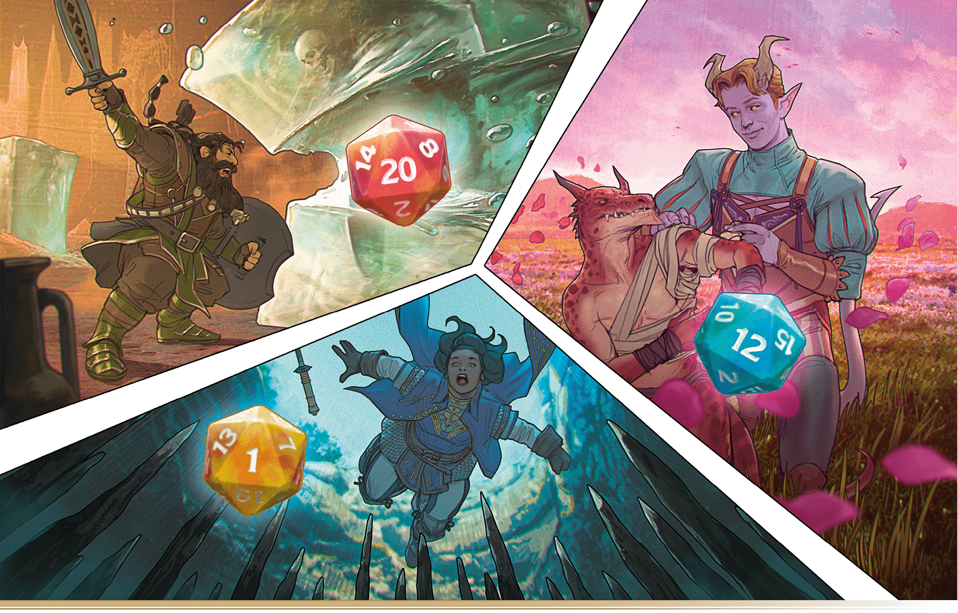](https://media.dndbeyond.com/compendium-images/phb/MKDHZ1nxSXDDLOw2/01-003.d20-test.png)A D20 Test can result in a dramatic success, a simple accomplishment, or a catastrophe

Ability Checks

An ability check represents a creature using talent and training to try to overcome a challenge, such as forcing open a stuck door, picking a lock, entertaining a crowd, or deciphering a cipher. The DM and the rules often call for an ability check when a creature attempts something other than an attack that has a chance of meaningful failure. When the outcome is uncertain and narratively interesting, the dice determine the result.

**Ability Modifier**

An ability check is named for the ability modifier it uses: a Strength check, an Intelligence check, and so on. Different ability checks are called for in different situations, depending on which ability is most relevant. See the Ability Check Examples table for examples of each check’s use.

| **Ability Check Examples** | |
| --- | --- |
| **Ability** | **Make a Check To...** |
| Strength | Lift, push, pull, or break something |
| Dexterity | Move nimbly, quickly, or quietly |
| Constitution | Push your body beyond normal limits |
| Intelligence | Reason or remember |
| Wisdom | Notice things in the environment or in creatures’ behavior |
| Charisma | Influence, entertain, or deceive |

**Proficiency Bonus**

Add your Proficiency Bonus to an ability check when the DM determines that a skill or tool proficiency is relevant to the check and you have that proficiency. For example, if a rule refers to a Strength ([**Acrobatics**](https://www.dndbeyond.com/sources/dnd/free-rules/playing-the-game#Skills) or [**Athletics**](https://www.dndbeyond.com/sources/dnd/free-rules/playing-the-game#Skills)) check, you can add your Proficiency Bonus to the check if you have proficiency in the [**Acrobatics**](https://www.dndbeyond.com/sources/dnd/free-rules/playing-the-game#Skills) or [**Athletics**](https://www.dndbeyond.com/sources/dnd/free-rules/playing-the-game#Skills) skill. See “[Proficiency](https://www.dndbeyond.com/sources/dnd/phb-2024/playing-the-game#Proficiency)” later in this chapter for more information about skill and tool proficiencies.

**Difficulty Class**

The Difficulty Class of an ability check represents the task’s difficulty. The more difficult the task, the higher its DC. The rules provide DCs for certain checks, but the DM ultimately sets them. The Typical Difficulty Classes table presents a range of possible DCs for ability checks.

| **Typical Difficulty Classes** | |
| --- | --- |
| **Task Difficulty** | **DC** |
| Very easy | 5 |
| Easy | 10 |
| Medium | 15 |
| Hard | 20 |
| Very hard | 25 |
| Nearly impossible | 30 |

Saving Throws

A saving throw—also called a save—represents an attempt to evade or resist a threat, such as a fiery explosion, a blast of poisonous gas, or a spell trying to invade your mind. You don’t normally choose to make a save; you must make one because your character or a monster (if you’re the DM) is at risk. A save’s result is detailed in the effect that caused it.

If you don’t want to resist the effect, you can choose to fail the save without rolling.

**Ability Modifier**

Saving throws are named for the ability modifiers they use: a Constitution saving throw, a Wisdom saving throw, and so on. Different saving throws are used to resist different kinds of effects, as shown on the Saving Throw Examples table.

| **Saving Throw Examples** | |
| --- | --- |
| **Ability** | **Make a Save To...** |
| Strength | Physically resist direct force |
| Dexterity | Dodge out of harm’s way |
| Constitution | Endure a toxic hazard |
| Intelligence | Recognize an illusion as fake |
| Wisdom | Resist a mental assault |
| Charisma | Assert your identity |

**Proficiency Bonus**

You add your Proficiency Bonus to your saving throw if you have proficiency in that kind of save. See “[Proficiency](https://www.dndbeyond.com/sources/dnd/phb-2024/playing-the-game#Proficiency)” later in this chapter.

**Difficulty Class**

The Difficulty Class for a saving throw is determined by the effect that causes it or by the DM. For example, if a spell forces you to make a save, the DC is determined by the caster’s spellcasting ability and Proficiency Bonus. Monster abilities that call for saves specify the DC.

Attack Rolls

An attack roll determines whether an attack hits a target. An attack roll hits if the roll equals or exceeds the target’s Armor Class. Attack rolls usually occur in battle, described in “[Combat](https://www.dndbeyond.com/sources/dnd/phb-2024/playing-the-game#Combat)” later in this chapter, but the DM might also ask for an attack roll in other situations, such as an archery competition.

**Ability Modifier**

The Attack Roll Abilities table shows which ability modifier to use for different types of attack rolls.

| **Attack Roll Abilities** | |
| --- | --- |
| **Ability** | **Attack Type** |
| Strength | Melee attack with a weapon or an [**Unarmed Strike**](https://www.dndbeyond.com/sources/dnd/free-rules/rules-glossary#UnarmedStrike) (see the [rules glossary](https://www.dndbeyond.com/sources/dnd/phb-2024/rules-glossary#UnarmedStrike)) |
| Dexterity | Ranged attack with a weapon |
| Varies | Spell attack (the ability used is determined by the spellcaster’s spellcasting feature, as explained in [chapter 7](https://www.dndbeyond.com/sources/dnd/phb-2024/spells)) |

Some features let you use different ability modifiers from those listed. For example, the [**Finesse**](https://www.dndbeyond.com/sources/dnd/free-rules/equipment#Finesse) property (see [chapter 6](https://www.dndbeyond.com/sources/dnd/phb-2024/equipment#Properties)) lets you use Strength or Dexterity with a weapon that has that property.

**Proficiency Bonus**

You add your Proficiency Bonus to your attack roll when you attack using a weapon you have proficiency with, as well as when you attack with a spell. See “[Proficiency](https://www.dndbeyond.com/sources/dnd/phb-2024/playing-the-game#Proficiency)” later in this chapter for more information about weapon proficiencies.

**Armor Class**

A creature’s Armor Class represents how well the creature avoids being wounded in combat. The AC of a character is determined at character creation (see [chapter 2](https://www.dndbeyond.com/sources/dnd/phb-2024/creating-a-character)), whereas the AC of a monster appears in its stat block.

***Calculating AC.*** All creatures start with the same base AC calculation:

**Base AC** = 10 + the creature’s Dexterity modifier

A creature’s AC can then be modified by armor, magic items, spells, and more.

***Only One Base AC.*** Some spells and class features give characters a different way to calculate their AC. A character with multiple features that give different ways to calculate AC must choose which one to use; only one base calculation can be in effect for a creature.

**Rolling 20 or 1**

If you roll a 20 on the d20 (called a “natural 20”) for an attack roll, the attack hits regardless of any modifiers or the target’s AC. This is called a Critical Hit (see “[Combat](https://www.dndbeyond.com/sources/dnd/phb-2024/playing-the-game#Combat)” later in this chapter).

If you roll a 1 on the d20 (a “natural 1”) for an attack roll, the attack misses regardless of any modifiers or the target’s AC.

Advantage/Disadvantage

**ALEJANDRO PACHECO**[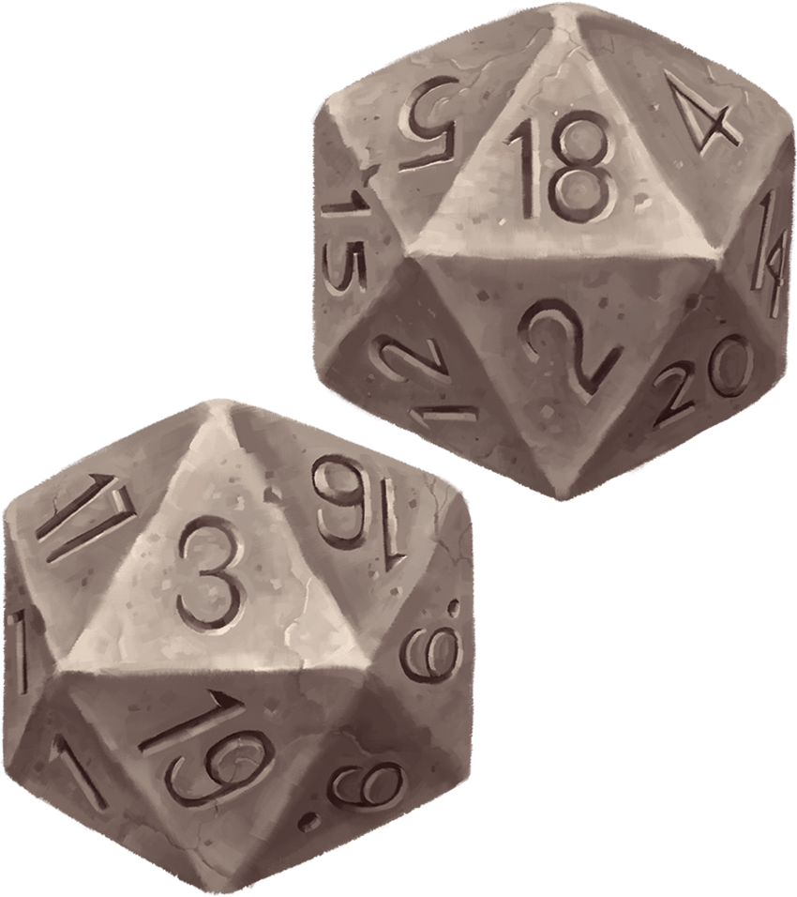](https://media.dndbeyond.com/compendium-images/phb/MKDHZ1nxSXDDLOw2/01-004.advantage-disadvantage.png)If you have Advantage, use the 18  
If you have Disadvantage, use the 3

Sometimes a [**D20 Test**](https://www.dndbeyond.com/sources/dnd/free-rules/rules-glossary#D20Test) is modified by Advantage or Disadvantage. Advantage reflects the positive circumstances surrounding a d20 roll, while Disadvantage reflects negative circumstances.

You usually acquire Advantage or Disadvantage through the use of special abilities and actions. The DM can also decide that circumstances grant Advantage or impose Disadvantage.

**Roll Two D20s**

When a roll has either Advantage or Disadvantage, roll a second d20 when you make the roll. Use the higher of the two rolls if you have Advantage, and use the lower roll if you have Disadvantage. For example, if you have Disadvantage and roll an 18 and a 3, use the 3. If you instead have Advantage and roll those numbers, use the 18.

**They Don’t Stack**

If multiple situations affect a roll and they all grant Advantage on it, you still roll only two d20s. Similarly, if multiple situations impose Disadvantage on a roll, you roll only two d20s.

If circumstances cause a roll to have both Advantage and Disadvantage, the roll has neither of them, and you roll one d20. This is true even if multiple circumstances impose Disadvantage and only one grants Advantage or vice versa. In such a situation, you have neither Advantage nor Disadvantage.

**Interactions with Rerolls**

When you have Advantage or Disadvantage and something in the game lets you reroll or replace the d20, you can reroll or replace only one die, not both. You choose which one.

For example, if you have [**Heroic Inspiration**](https://www.dndbeyond.com/sources/dnd/free-rules/rules-glossary#HeroicInspiration) (see the sidebar) and roll a 3 and an 18 on an ability check that has Advantage or Disadvantage, you could expend your Heroic Inspiration to reroll one of those dice, not both of them.

**Heroic Inspiration**

Sometimes the DM or a rule gives you Heroic Inspiration. If you have Heroic Inspiration, you can expend it to reroll any die immediately after rolling it, and you must use the new roll.

***Only One at a Time.*** You can never have more than one instance of Heroic Inspiration. If something gives you Heroic Inspiration and you already have it, you can give it to a player character in your group who lacks it.

***Gaining Heroic Inspiration.*** Your DM can give you Heroic Inspiration for a variety of reasons. Typically, DMs award it when you do something particularly heroic, in character, or entertaining. It’s a reward for making the game more fun for everyone playing.

Other rules might allow your character to gain Heroic Inspiration independent of the DM’s decision. For example, Human characters start each day with Heroic Inspiration.

Proficiency

Characters and monsters are good at various things. Some are skilled with many weapons, while others can use only a few. Some are better at understanding people’s motives, and others are better at unlocking the secrets of the multiverse. All creatures have a Proficiency Bonus, which reflects the impact that training has on the creature’s capabilities. A character’s Proficiency Bonus increases as the character gains levels (described in [chapter 2](https://www.dndbeyond.com/sources/dnd/phb-2024/creating-a-character)). A monster’s Proficiency Bonus is based on its [**Challenge Rating**](https://www.dndbeyond.com/sources/dnd/free-rules/rules-glossary#ChallengeRating) (see the [rules glossary](https://www.dndbeyond.com/sources/dnd/phb-2024/rules-glossary#ChallengeRating)). The Proficiency Bonus table shows how the bonus is determined.

This bonus is applied to a [**D20 Test**](https://www.dndbeyond.com/sources/dnd/free-rules/rules-glossary#D20Test) when the creature has proficiency in a skill, in a saving throw, or with an item that the creature uses to make the D20 Test. The bonus is also used for spell attacks and for calculating the DC of saving throws for spells.

| **Proficiency Bonus** | |
| --- | --- |
| **Level or CR** | **Bonus** |
| Up to 4 | +2 |
| 5–8 | +3 |
| 9–12 | +4 |
| 13–16 | +5 |
| 17–20 | +6 |
| 21–24 | +7 |
| 25–28 | +8 |
| 29–30 | +9 |

The Bonus Doesn’t Stack

Your Proficiency Bonus can’t be added to a die roll or another number more than once. For example, if a rule allows you to make a Charisma ([**Deception**](https://www.dndbeyond.com/sources/dnd/free-rules/playing-the-game#Skills) or [**Persuasion**](https://www.dndbeyond.com/sources/dnd/free-rules/playing-the-game#Skills)) check, you add your Proficiency Bonus if you’re proficient in either skill, but you don’t add it twice if you’re proficient in both skills.

Occasionally, a Proficiency Bonus might be multiplied or divided (doubled or halved, for example) before being added. For example, the [**Expertise**](https://www.dndbeyond.com/sources/dnd/free-rules/rules-glossary#Expertise) feature (see the [rules glossary](https://www.dndbeyond.com/sources/dnd/phb-2024/rules-glossary#Expertise)) doubles the Proficiency Bonus for certain ability checks. Whenever the bonus is used, it can be multiplied only once and divided only once.

Skill Proficiencies

Most ability checks involve using a skill, which represents a category of things creatures try to do with an ability check. The descriptions of the actions you take (see ["Actions"](https://www.dndbeyond.com/sources/dnd/phb-2024/playing-the-game#Actions) later in this chapter) specify which skill applies if you make an ability check for that action, and many other rules note when a skill is relevant. The DM has the ultimate say on whether a skill is relevant in a situation.

If a creature is proficient in a skill, the creature applies its Proficiency Bonus to ability checks involving that skill. Without proficiency in a skill, a creature can still make ability checks involving that skill but doesn’t add its Proficiency Bonus. For example, if a character tries to climb a cliff, the DM might ask for a Strength ([**Athletics**](https://www.dndbeyond.com/sources/dnd/free-rules/playing-the-game#Skills)) check. If the character has [**Athletics**](https://www.dndbeyond.com/sources/dnd/free-rules/playing-the-game#Skills) proficiency, the character adds their Proficiency Bonus to the Strength check. If the character lacks that proficiency, they make the check without adding their Proficiency Bonus.

**Skill List**

The skills are shown on the Skills table, which notes example uses for each skill proficiency as well as the ability check the skill most often applies to.

| **Skills** | | |
| --- | --- | --- |
| **Skill** | **Ability** | **Example Uses** |
| [**Acrobatics**](https://www.dndbeyond.com/sources/dnd/free-rules/playing-the-game#Skills) | Dexterity | Stay on your feet in a tricky situation, or perform an acrobatic stunt. |
| [**Animal Handling**](https://www.dndbeyond.com/sources/dnd/free-rules/playing-the-game#Skills) | Wisdom | Calm or train an animal, or get an animal to behave in a certain way. |
| [**Arcana**](https://www.dndbeyond.com/sources/dnd/free-rules/playing-the-game#Skills) | Intelligence | Recall lore about spells, magic items, and the planes of existence. |
| [**Athletics**](https://www.dndbeyond.com/sources/dnd/free-rules/playing-the-game#Skills) | Strength | Jump farther than normal, stay afloat in rough water, or break something. |
| [**Deception**](https://www.dndbeyond.com/sources/dnd/free-rules/playing-the-game#Skills) | Charisma | Tell a convincing lie, or wear a disguise convincingly. |
| [**History**](https://www.dndbeyond.com/sources/dnd/free-rules/playing-the-game#Skills) | Intelligence | Recall lore about historical events, people, nations, and cultures. |
| [**Insight**](https://www.dndbeyond.com/sources/dnd/free-rules/playing-the-game#Skills) | Wisdom | Discern a person’s mood and intentions. |
| [**Intimidation**](https://www.dndbeyond.com/sources/dnd/free-rules/playing-the-game#Skills) | Charisma | Awe or threaten someone into doing what you want. |
| [**Investigation**](https://www.dndbeyond.com/sources/dnd/free-rules/playing-the-game#Skills) | Intelligence | Find obscure information in books, or deduce how something works. |
| [**Medicine**](https://www.dndbeyond.com/sources/dnd/free-rules/playing-the-game#Skills) | Wisdom | Diagnose an illness, or determine what killed the recently slain. |
| [**Nature**](https://www.dndbeyond.com/sources/dnd/free-rules/playing-the-game#Skills) | Intelligence | Recall lore about terrain, plants, animals, and weather. |
| [**Perception**](https://www.dndbeyond.com/sources/dnd/free-rules/playing-the-game#Skills) | Wisdom | Using a combination of senses, notice something that’s easy to miss. |
| [**Performance**](https://www.dndbeyond.com/sources/dnd/free-rules/playing-the-game#Skills) | Charisma | Act, tell a story, perform music, or dance. |
| [**Persuasion**](https://www.dndbeyond.com/sources/dnd/free-rules/playing-the-game#Skills) | Charisma | Honestly and graciously convince someone of something. |
| [**Religion**](https://www.dndbeyond.com/sources/dnd/free-rules/playing-the-game#Skills) | Intelligence | Recall lore about gods, religious rituals, and holy symbols. |
| [**Sleight of Hand**](https://www.dndbeyond.com/sources/dnd/free-rules/playing-the-game#Skills) | Dexterity | Pick a pocket, conceal a handheld object, or perform legerdemain. |
| [**Stealth**](https://www.dndbeyond.com/sources/dnd/free-rules/playing-the-game#Skills) | Dexterity | Escape notice by moving quietly and hiding behind things. |
| [**Survival**](https://www.dndbeyond.com/sources/dnd/free-rules/playing-the-game#Skills) | Wisdom | Follow tracks, forage, find a trail, or avoid natural hazards. |

**Determining Skills**

A character’s starting skill proficiencies are determined at character creation, and a monster’s skill proficiencies appear in its stat block.

**Skills with Different Abilities**

Each skill proficiency is associated with an ability check. For example, the [**Intimidation**](https://www.dndbeyond.com/sources/dnd/free-rules/playing-the-game#Skills) skill is associated with Charisma. In some situations, the DM might allow you to apply your skill proficiency to a different ability check. For example, if a character tries to intimidate someone through a show of physical strength, the DM might ask for a Strength ([**Intimidation**](https://www.dndbeyond.com/sources/dnd/free-rules/playing-the-game#Skills)) check rather than a Charisma ([**Intimidation**](https://www.dndbeyond.com/sources/dnd/free-rules/playing-the-game#Skills)) check. That character would make a Strength check and add their Proficiency Bonus if they have [**Intimidation**](https://www.dndbeyond.com/sources/dnd/free-rules/playing-the-game#Skills) proficiency.

Saving Throw Proficiencies

Proficiency in a saving throw lets a character add their Proficiency Bonus to saves that use a particular ability. For example, proficiency in Wisdom saves lets you add your Proficiency Bonus to your Wisdom saves. Some monsters also have saving throw proficiencies, as noted in their stat blocks.

Each class gives proficiency in at least two saving throws, representing that class’s training in evading or resisting certain threats. Wizards, for example, are proficient in Intelligence and Wisdom saves; they train to resist mental assault.

Equipment Proficiencies

A character gains proficiency with various weapons and tools from their class and background. There are two categories of equipment proficiency:

**Weapons.** Anyone can wield a weapon, but proficiency makes you better at wielding it. If you have proficiency with a weapon, you add your Proficiency Bonus to attack rolls you make with it.

**Tools.** If you have proficiency with a tool, you can add your Proficiency Bonus to any ability check you make that uses the tool. If you have proficiency in the skill that’s also used with that check, you have Advantage on the check too. This means you can benefit from both skill proficiency and tool proficiency on the same ability check.

Actions

When you do something other than moving or communicating, you typically take an action. The Action table lists the game’s main actions, which are defined in more detail in the [rules glossary](https://www.dndbeyond.com/sources/dnd/phb-2024/rules-glossary).

| **Actions** | |
| --- | --- |
| **Action** | **Summary** |
| [**Attack**](https://www.dndbeyond.com/sources/dnd/free-rules/rules-glossary#AttackAction) | Attack with a weapon or an [**Unarmed Strike**](https://www.dndbeyond.com/sources/dnd/free-rules/rules-glossary#UnarmedStrike). |
| [**Dash**](https://www.dndbeyond.com/sources/dnd/free-rules/rules-glossary#DashAction) | For the rest of the turn, give yourself extra movement equal to your [**Speed**](https://www.dndbeyond.com/sources/dnd/free-rules/rules-glossary#Speed). |
| [**Disengage**](https://www.dndbeyond.com/sources/dnd/free-rules/rules-glossary#DisengageAction) | Your movement doesn’t provoke [**Opportunity Attack**](https://www.dndbeyond.com/sources/dnd/free-rules/rules-glossary#OpportunityAttack) for the rest of the turn. |
| [**Dodge**](https://www.dndbeyond.com/sources/dnd/free-rules/rules-glossary#DodgeAction) | Until the start of your next turn, attack rolls against you have [**Disadvantage**](https://www.dndbeyond.com/sources/dnd/free-rules/rules-glossary#Disadvantage), and you make Dexterity saving throws with [**Advantage**](https://www.dndbeyond.com/sources/dnd/free-rules/rules-glossary#Advantage). You lose this benefit if you have the [**Incapacitated**](https://www.dndbeyond.com/sources/dnd/free-rules/rules-glossary#IncapacitatedCondition) condition or if your Speed is 0. |
| [**Help**](https://www.dndbeyond.com/sources/dnd/free-rules/rules-glossary#HelpAction) | Help another creature’s ability check or attack roll, or administer first aid. |
| [**Hide**](https://www.dndbeyond.com/sources/dnd/free-rules/rules-glossary#HideAction) | Make a Dexterity ([**Stealth**](https://www.dndbeyond.com/sources/dnd/free-rules/playing-the-game#Skills)) check. |
| [**Influence**](https://www.dndbeyond.com/sources/dnd/free-rules/rules-glossary#InfluenceAction) | Make a Charisma ([**Deception**](https://www.dndbeyond.com/sources/dnd/free-rules/playing-the-game#Skills), [**Intimidation**](https://www.dndbeyond.com/sources/dnd/free-rules/playing-the-game#Skills), [**Performance**](https://www.dndbeyond.com/sources/dnd/free-rules/playing-the-game#Skills), or [**Persuasion**](https://www.dndbeyond.com/sources/dnd/free-rules/playing-the-game#Skills)) or Wisdom ([**Animal Handling**](https://www.dndbeyond.com/sources/dnd/free-rules/playing-the-game#Skills)) check to alter a creature’s attitude. |
| [**Magic**](https://www.dndbeyond.com/sources/dnd/free-rules/rules-glossary#MagicAction) | Cast a spell, use a magic item, or use a magical feature. |
| [**Ready**](https://www.dndbeyond.com/sources/dnd/free-rules/rules-glossary#ReadyAction) | Prepare to take an action in response to a trigger you define. |
| [**Search**](https://www.dndbeyond.com/sources/dnd/free-rules/rules-glossary#SearchAction) | Make a Wisdom ([**Insight**](https://www.dndbeyond.com/sources/dnd/free-rules/playing-the-game#Skills), [**Medicine**](https://www.dndbeyond.com/sources/dnd/free-rules/playing-the-game#Skills), [**Perception**](https://www.dndbeyond.com/sources/dnd/free-rules/playing-the-game#Skills), or [**Survival**](https://www.dndbeyond.com/sources/dnd/free-rules/playing-the-game#Skills)) check. |
| [**Study**](https://www.dndbeyond.com/sources/dnd/free-rules/rules-glossary#StudyAction) | Make an Intelligence ([**Arcana**](https://www.dndbeyond.com/sources/dnd/free-rules/playing-the-game#Skills), [**History**](https://www.dndbeyond.com/sources/dnd/free-rules/playing-the-game#Skills), [**Investigation**](https://www.dndbeyond.com/sources/dnd/free-rules/playing-the-game#Skills), [**Nature**](https://www.dndbeyond.com/sources/dnd/free-rules/playing-the-game#Skills), or [**Religion**](https://www.dndbeyond.com/sources/dnd/free-rules/playing-the-game#Skills)) check. |
| [**Utilize**](https://www.dndbeyond.com/sources/dnd/free-rules/rules-glossary#UtilizeAction) | Use a nonmagical object. |

Player characters and monsters can also do things not covered by these actions. Many class features and other abilities provide additional action options, and you can improvise other actions. When you describe an action not detailed elsewhere in the rules, the Dungeon Master tells you whether that action is possible and what kind of [**D20 Test**](https://www.dndbeyond.com/sources/dnd/free-rules/rules-glossary#D20Test) you need to make, if any.

One Thing at a Time

The game uses actions to govern how much you can do at one time. You can take only one action at a time. This principle is most important in combat, as explained in “[Combat](https://www.dndbeyond.com/sources/dnd/phb-2024/playing-the-game#Combat)” later in this chapter.

Actions can come up in other situations, too: in a social interaction, you can try to [**Influence**](https://www.dndbeyond.com/sources/dnd/free-rules/rules-glossary#InfluenceAction) a creature or use the [**Search**](https://www.dndbeyond.com/sources/dnd/free-rules/rules-glossary#SearchAction) action to read the creature’s body language, but you can’t do both at the same time. And when you’re exploring a dungeon, you can’t simultaneously use the [**Search**](https://www.dndbeyond.com/sources/dnd/free-rules/rules-glossary#SearchAction) action to look for traps and use the [**Help**](https://www.dndbeyond.com/sources/dnd/free-rules/rules-glossary#HelpAction) action to aid another character who’s trying to open a stuck door (with the [**Utilize**](https://www.dndbeyond.com/sources/dnd/free-rules/rules-glossary#UtilizeAction) action).

Bonus Actions

Various class features, spells, and other abilities let you take an additional action on your turn called a Bonus Action. The Cunning Action feature, for example, allows a Rogue to take a Bonus Action. You can take a Bonus Action only when a special ability, a spell, or another feature of the game states that you can do something as a Bonus Action. You otherwise don’t have a Bonus Action to take.

You can take only one Bonus Action on your turn, so you must choose which Bonus Action to use if you have more than one available.

You choose when to take a Bonus Action during your turn unless the Bonus Action’s timing is specified. Anything that deprives you of your ability to take actions also prevents you from taking a Bonus Action.

Reactions

Certain special abilities, spells, and situations allow you to take a special action called a Reaction. A Reaction is an instant response to a trigger of some kind, which can occur on your turn or on someone else’s. The [**Opportunity Attack**](https://www.dndbeyond.com/sources/dnd/free-rules/rules-glossary#OpportunityAttack), described [later in this chapter](https://www.dndbeyond.com/sources/dnd/phb-2024/playing-the-game#OpportunityAttacks), is the most common type of Reaction.

When you take a Reaction, you can’t take another one until the start of your next turn. If the reaction interrupts another creature’s turn, that creature can continue its turn right after the Reaction.

In terms of timing, a Reaction takes place immediately after its trigger unless the Reaction’s description says otherwise.

**What Would Your Character Do?**

Ask yourself as you play, “What would my character do?” Playing a role involves some amount of getting into another person’s head and understanding what motivates them and how those motivations translate into action. In D&D, those actions unfold against the backdrop of a fantastic world full of situations we can only imagine. How does your character react to those situations?

This advice comes with one important caveat: avoid character choices that ruin the fun of the other players and the DM. Choose actions that delight you and your friends.

Social Interaction

**LINDA LITHEN**[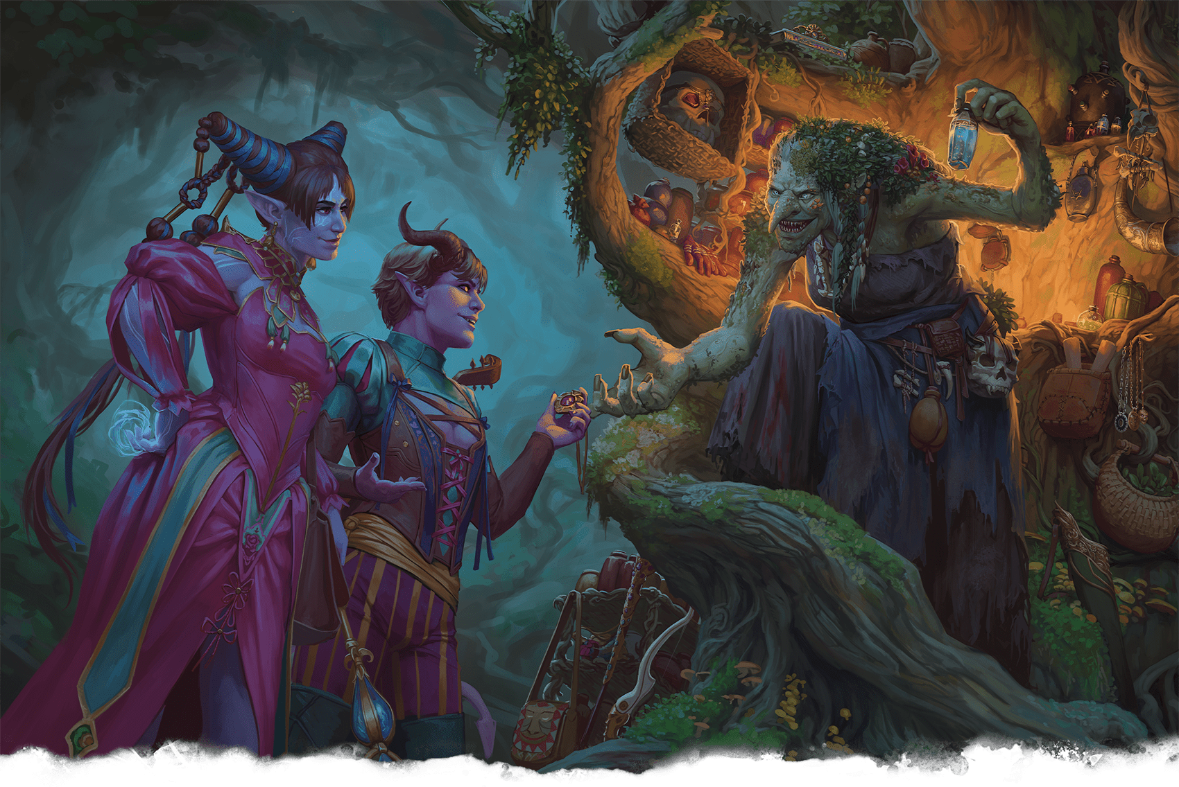](https://media.dndbeyond.com/compendium-images/phb/MKDHZ1nxSXDDLOw2/01-005.adventurers-bartering.png)Characters lay on the charm while bartering for magic items with a green hag

During their adventures, player characters meet many different people and face some monsters that would rather talk than fight. In those situations, it’s time for social interaction, which takes many forms. For example, you might try to convince a burglar to confess to wrongdoing or try to flatter a guard. The Dungeon Master assumes the roles of any nonplayer characters who are participating.

An NPC’s attitude toward your character is [**Friendly**](https://www.dndbeyond.com/sources/dnd/free-rules/rules-glossary#FriendlyAttitude), [**Indifferent**](https://www.dndbeyond.com/sources/dnd/free-rules/rules-glossary#IndifferentAttitude), or [**Hostile**](https://www.dndbeyond.com/sources/dnd/free-rules/rules-glossary#HostileAttitude), as defined in the [rules glossary](https://www.dndbeyond.com/sources/dnd/phb-2024/rules-glossary). Friendly NPCs are predisposed to help, and Hostile ones are inclined to hinder.

Social interactions progress in two ways: through roleplaying and ability checks.

Roleplaying

Roleplaying is, literally, the act of playing out a role. In this case, it’s you as a player determining how your character thinks, acts, and talks. Roleplaying is part of every aspect of the game, and it comes to the fore during social interactions.

As you roleplay, consider whether you prefer an active approach or a descriptive approach, each of which is described in “[Social Interaction Example.](https://www.dndbeyond.com/sources/dnd/phb-2024/playing-the-game#SocialInteractionExample)”

The DM uses an NPC’s personality and your character’s actions and attitudes to determine how an NPC reacts. A cowardly bandit might buckle under threats of imprisonment. A stubborn merchant refuses to help if the characters badger her. A vain dragon laps up flattery.

When interacting with an NPC, pay attention to the DM’s portrayal of the NPC’s personality. You might be able to learn an NPC’s goals and then use that information to influence the NPC.

If you offer NPCs something they want or play on their sympathies, fears, or goals, you can form friendships, ward off violence, or learn a key piece of information. On the other hand, if you insult a proud warrior or speak ill of a noble’s allies, your efforts to convince or deceive will likely fail.

Ability Checks

Ability checks can be key in determining the outcome of a social interaction. Your roleplaying efforts can alter an NPC’s attitude, but there might still be an element of chance if the DM wants dice to play a role in determining an NPC’s response to you. In such situations, the DM will typically ask you to take the [**Influence**](https://www.dndbeyond.com/sources/dnd/free-rules/rules-glossary#InfluenceAction) action.

Pay attention to your skill proficiencies when thinking of how you will interact with an NPC; use an approach that relies on your group’s skill proficiencies. For example, if the group needs to trick a guard into letting them into a castle, the Rogue who is proficient in [**Deception**](https://www.dndbeyond.com/sources/dnd/free-rules/playing-the-game#Skills) should lead the discussion.

Social Interaction Example

**JOHN GRELLO**[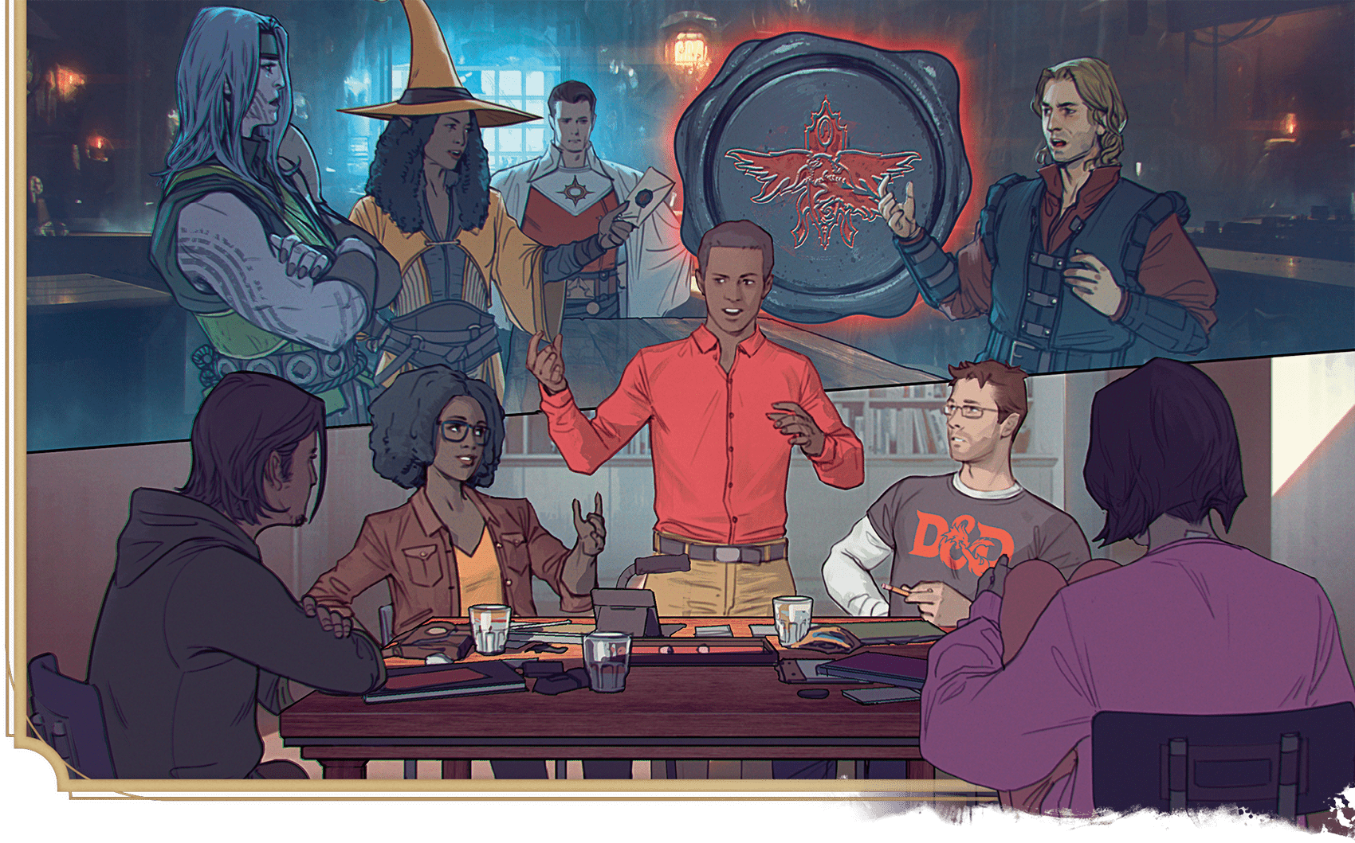](https://media.dndbeyond.com/compendium-images/phb/MKDHZ1nxSXDDLOw2/01-006.social-interaction-example.png)

In this scene, players engage in a social interaction encounter. You and your group determine how similar scenes play out in your adventures.

*Four adventurers—Shreeve, Mirabella, Auro, and Gareth—have traveled to the Blood on the Vine tavern in the grim village of Barovia.*

**Jared (as DM):** This tavern might have been finely appointed once, but it has grown shoddy with the passage of years. A blazing fire in the hearth barely gives any warmth to the room. You see a man behind the counter, methodically cleaning glasses. Three older women huddle together at one table. And a handsome young man sits by himself at a corner table, sipping a glass of wine. He looks up as you enter, but the other people ignore you. “Welcome to Barovia,” he says. He holds a coin toward the bartender: “A pitcher for the visitors.” The glint of silver catches the server’s attention.

**Maeve (as Mirabella):** “Thank you, friend. May we know to whom we’re indebted?”

**Jared:** “I am Ismark Kolyanovich, though around here, I am often called Ismark the Lesser.”

**Russell (as Shreeve):** “That’s unfortunate.”

**Jared:** “Indeed. I hope one day to live up to my father’s example and rid myself of that title. And so, my new friends, who are you?”

**Amy (as Auro):** “I’m Auro.”

**Russell:** “Shreeve.”

**Phillip (as Gareth):** “My name is Gareth.”

**Maeve (as Mirabella):** “I’m called Mirabella. You said your name was Kolyanovich. Are you related to Kolyan Indirovich, the burgomaster of this town?”

**Jared:** He looks a little surprised. He says, “Kolyan Indirovich is my esteemed father, yes.”

**Active Roleplaying.** Notice throughout the example how Russell and Amy actively roleplay their characters’ behavior. In this active approach, they speak with their characters’ voices, like an actor taking on a role. The players might even echo their characters’ body language. They still need to describe things that can’t reasonably be acted out.

**Descriptive Roleplaying.** Notice how Phillip describes his character’s words and action. Drawing on his mental image of his character, he says what his character does and how the character does it. If this approach is most comfortable for you, keep these things in mind:

* Describe your character’s emotions and attitude.
* Focus on your character’s intent and how others might perceive it.
* Provide as much embellishment as you feel comfortable with.

Don’t worry about getting things exactly right. Focus on what your character would do, and describe what you see in your mind.

**Maeve:** “Then he’s the one who summoned us!” I show him the letter that drew us here.

**Phillip:** I watch his reaction as he reads it.

**1**

**Jared:** He reaches for the letter but pulls back before touching it. “That seal—it’s not my father’s.” Gareth, make a Wisdom (Insight) check.

**Phillip:** Gareth got 18.

**Jared:** You notice that Ismark is trying to conceal his terror. He’s afraid to even touch the letter’s seal.

**Phillip:** I ask him what’s frightening him.

**1**

**Ability Checks.** Phillip’s character, Gareth, makes a Wisdom ([**Insight**](https://www.dndbeyond.com/sources/dnd/free-rules/playing-the-game#Skills)) check to determine whether he reads Ismark’s unspoken cues. Wisdom is the ability that measures perceptiveness and intuition. Insight reflects a character’s skill at reading other people’s moods and intentions. The DM set the DC at 15, which Gareth beats. With a successful Wisdom ([**Insight**](https://www.dndbeyond.com/sources/dnd/free-rules/playing-the-game#Skills)) check, Gareth gleans information that wasn’t obvious, so it wasn’t part of the DM’s earlier narration. For more information, see “[Ability Scores](https://www.dndbeyond.com/sources/dnd/phb-2024/playing-the-game#TheSixAbilities)” and “[Proficiency](https://www.dndbeyond.com/sources/dnd/phb-2024/playing-the-game#Proficiency)” earlier in this chapter and the [**Search**](https://www.dndbeyond.com/sources/dnd/free-rules/rules-glossary#SearchAction) action in the [rules glossary](https://www.dndbeyond.com/sources/dnd/phb-2024/rules-glossary#SearchAction).

**Russell:** “Yeah, whose seal is it?”

**Jared:** “The Devil Strahd.”

**Amy:** “Sounds like a pleasant fellow.”

**Jared:** “No! He is the vampire lord of Castle Ravenloft and a plague to my sister. You must help her!”

**Amy:** “So Strahd wrote this letter, pretending to be the burgomaster, imploring us to come to Barovia and rescue Ireena Kolyana from a deadly affliction... which is him? Why would he do that?”

**Russell:** “Why would he want us to come here?”

**Maeve:** “Clearly, he doesn’t think we’re a threat.”

**Amy:** “Well, he hasn’t met us yet!”

**Jared:** “He’s toying with you. He delights in the destruction of all things good, like my dear sister.”

**2**

**Phillip:** Gareth draws closer and compassionately asks Ismark whether his sister has been bitten by the vampire.

**Jared:** Please make a Charisma (Persuasion) check to see how well he responds to your pastoral manner. You have Advantage because he’s Friendly.

**Phillip:** Oh, good thing. My first roll was a 7, but with Advantage... ugh, not much better. Well, 10 plus 5 is 15.

**2**

**Influencing NPCs.** Gareth takes the [**Influence**](https://www.dndbeyond.com/sources/dnd/free-rules/rules-glossary#InfluenceAction) action (see the [rules glossary](https://www.dndbeyond.com/sources/dnd/phb-2024/rules-glossary#InfluenceAction)), which characters can take to influence an NPC. It’s easier to influence an NPC who’s already disposed to help you, as Ismark is here. Ismark’s [**Friendly**](https://www.dndbeyond.com/sources/dnd/free-rules/rules-glossary#FriendlyAttitude) attitude gives Phillip Advantage on the roll. In this case, [**Advantage**](https://www.dndbeyond.com/sources/dnd/free-rules/rules-glossary#Advantage) made the difference between success and failure.

**Jared:** Ismark leans toward you, Gareth, with a suspicious glance at the other people in the tavern, like he’s worried they’re eavesdropping. He whispers, “The Devil Strahd desires to make Ireena his latest plaything. Twice he has visited her in the night, using his devilry to secure an invitation into the house—for he can’t enter where he isn’t invited. Twice he has bitten her, yet she clings to life. But I fear she won’t survive another visit!”

**Russell:** “All right, Ismark. You bought us drinks and told us about the Devil Strahd and your sister. How can we help?”

**Jared:** “You are too kind! First, I need your help transporting Ireena to the town of Vallaki.”

**Maeve:** “Where’s Vallaki?”

**Jared:** “It lies to the northwest, in the heart of the valley. As the raven flies, it is less than ten miles, but the road winds among the hills and woods, and the journey takes at least five hours at speed.”

**Russell:** “And why there?”

**Jared:** “The town lies beyond the view of Castle Ravenloft, so I hope it’s beyond Strahd’s spies. And I have heard that Vallaki is well defended, with a wooden palisade and iron gates.”

**Russell:** “As if such defenses would stop a vampire.”

**Jared:** “Indeed. But if moving her there can keep him away from her for even a few days, we have time for the second part of our task.”

**Russell:** “A part where you help us?”

**Jared:** “Yes, when I help you face the vampire!”

Exploration

Exploration involves delving into places that are dangerous and full of mystery. The rules in this section detail some of the ways adventurers interact with the environment in such places.

Adventuring Equipment

As adventurers explore, their equipment can help them in many ways. For example, they can reach out-of-the-way places with a Ladder, perceive things they wouldn’t otherwise notice with a Torch or another light source, bypass locked doors and containers with [**Thieves’ Tools**](https://www.dndbeyond.com/equipment/495-thieves-tools), and create obstacles for pursuers with [**Caltrops**](https://www.dndbeyond.com/equipment/497-caltrops).

See [chapter 6](https://www.dndbeyond.com/sources/dnd/phb-2024/equipment) for rules on many items that are useful on adventures. The items in that chapter’s “[Tools](https://www.dndbeyond.com/sources/dnd/phb-2024/equipment#Tools)” and “[Adventuring Gear](https://www.dndbeyond.com/sources/dnd/phb-2024/equipment#AdventuringGear)” sections are especially useful. The weapons in that chapter can also be used for more than battle; you could use a [**Quarterstaff**](https://www.dndbeyond.com/equipment/12-quarterstaff), for example, to push a sinister-looking button that you’re reluctant to touch.

Vision and Light

**DAVID ASTRUGA**[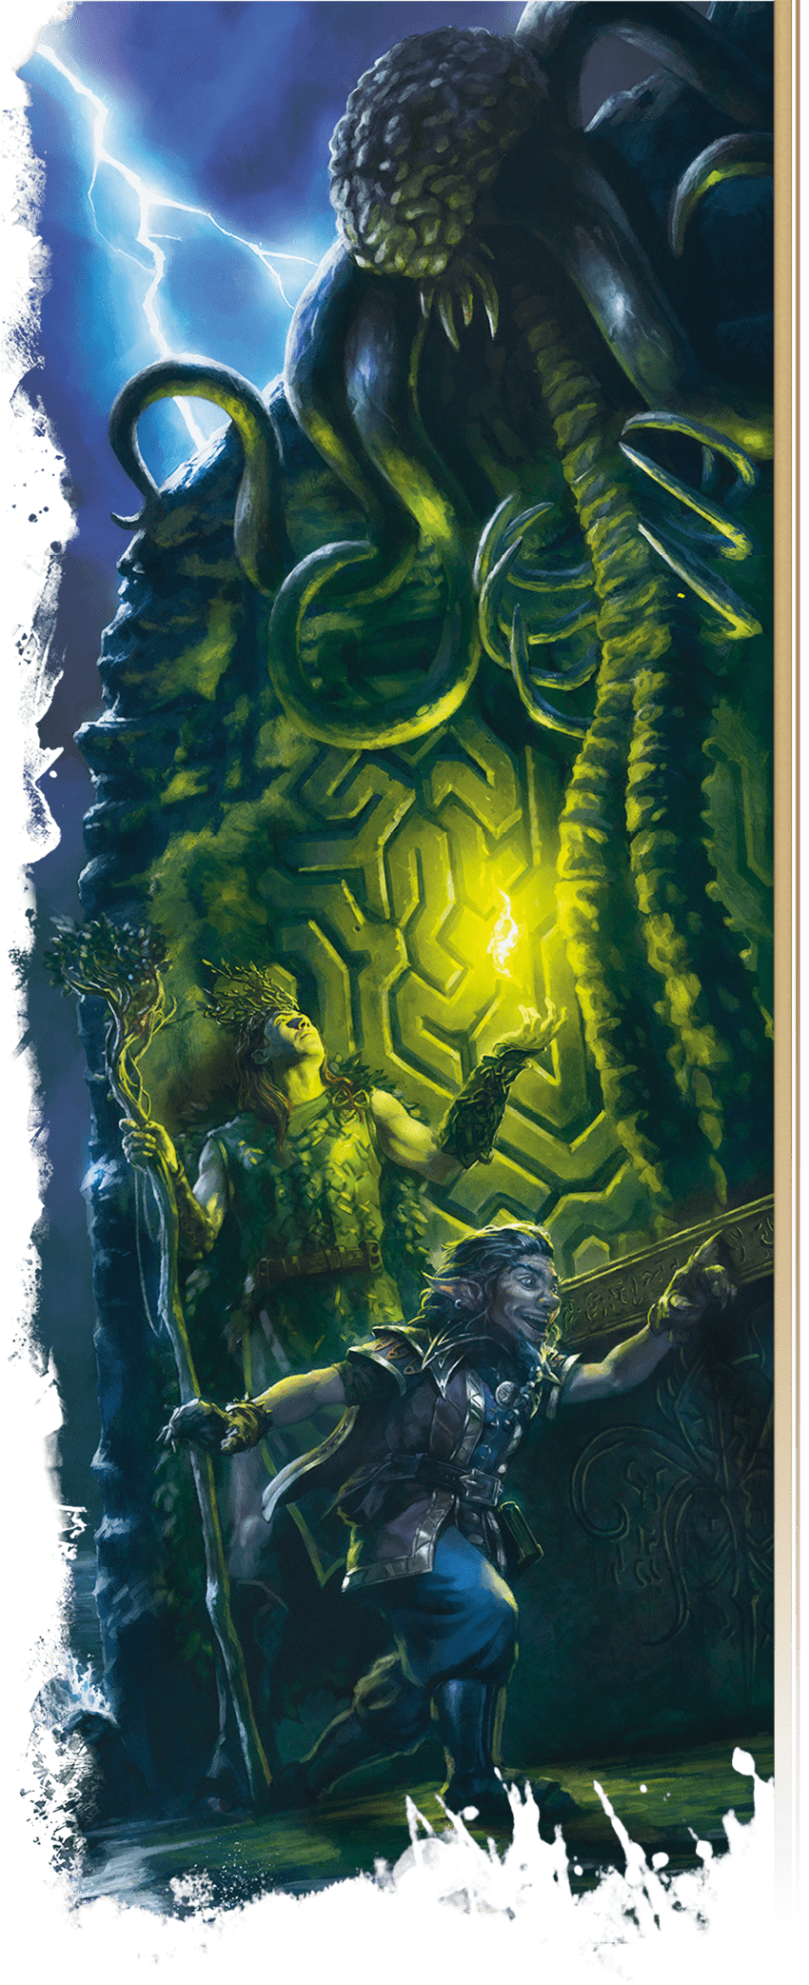](https://media.dndbeyond.com/compendium-images/phb/MKDHZ1nxSXDDLOw2/01-007.obscured-exploration.png)

Some adventuring tasks—such as noticing danger, hitting an enemy, and targeting certain spells—are affected by sight, so effects that obscure vision can hinder you, as explained below.

**Obscured Areas**

An area might be Lightly or Heavily Obscured. In a Lightly Obscured area—such as an area with Dim Light, patchy fog, or moderate foliage—you have [**Disadvantage**](https://www.dndbeyond.com/sources/dnd/free-rules/rules-glossary#Disadvantage) on Wisdom ([**Perception**](https://www.dndbeyond.com/sources/dnd/free-rules/playing-the-game#Skills)) checks that rely on sight.

A Heavily Obscured area—such as an area with Darkness, heavy fog, or dense foliage—is opaque. You have the [**Blinded**](https://www.dndbeyond.com/sources/dnd/free-rules/rules-glossary#BlindedCondition) condition (see the [rules glossary](https://www.dndbeyond.com/sources/dnd/phb-2024/rules-glossary#BlindedCondition)) when trying to see something there.

**Light**

The presence or absence of light determines the category of illumination in an area, as defined below.

***Bright Light.*** Bright Light lets most creatures see normally. Even gloomy days provide Bright Light, as do torches, lanterns, fires, and other sources of illumination within a specific radius.

***Dim Light.*** Dim Light, also called shadows, creates a [**Lightly Obscured**](https://www.dndbeyond.com/sources/dnd/free-rules/rules-glossary#LightlyObscured) area. An area of Dim Light is usually a boundary between Bright Light and surrounding Darkness. The soft light of twilight and dawn also counts as Dim Light. A full moon might bathe the land in Dim Light.

***Darkness.*** Darkness creates a [**Heavily Obscured**](https://www.dndbeyond.com/sources/dnd/free-rules/rules-glossary#HeavilyObscured) area. Characters face Darkness outdoors at night (even most moonlit nights), within the confines of an unlit dungeon, or in an area of magical Darkness.

**Special Senses**

Some creatures have special senses that help them perceive things in certain situations. The rules glossary defines the following special senses:

* [**Blindsight**](https://www.dndbeyond.com/sources/dnd/free-rules/rules-glossary#Blindsight)
* [**Darkvision**](https://www.dndbeyond.com/sources/dnd/free-rules/rules-glossary#Darkvision)
* [**Tremorsense**](https://www.dndbeyond.com/sources/dnd/free-rules/rules-glossary#Tremorsense)
* [**Truesight**](https://www.dndbeyond.com/sources/dnd/free-rules/rules-glossary#Truesight)

Hiding

Adventurers and monsters often hide, whether to spy on one another, sneak past a guardian, or set an ambush. The Dungeon Master decides when circumstances are appropriate for hiding. When you try to hide, you take the [**Hide**](https://www.dndbeyond.com/sources/dnd/free-rules/rules-glossary#HideAction) action.

Interacting with Objects

Interacting with objects is often simple to resolve. The player tells the DM that their character is doing something, such as moving a lever or opening a door, and the DM describes what happens. Sometimes, however, rules govern what you can do with an object, as detailed in the following sections.

**What Is an Object?**

For the purpose of the rules, an object is a discrete, inanimate item like a window, door, sword, book, table, chair, or stone. It isn’t a building or a vehicle, which are composed of many objects.

**Time-Limited Object Interactions**

When time is short, such as in combat, interactions with objects are limited: one free interaction per turn. That interaction must occur during a creature’s movement or action. Any additional interactions require the [**Utilize**](https://www.dndbeyond.com/sources/dnd/free-rules/rules-glossary#UtilizeAction) action, as explained in “[Combat](https://www.dndbeyond.com/sources/dnd/phb-2024/playing-the-game#Combat)” later in this chapter.

**Finding Hidden Objects**

When your character searches for hidden things, such as a secret door or a trap, the DM typically asks you to make a Wisdom ([**Perception**](https://www.dndbeyond.com/sources/dnd/free-rules/playing-the-game#Skills)) check, provided you describe the character searching in the hidden object’s vicinity. On a success, you find the object, other important details, or both.

If you describe your character searching nowhere near a hidden object, a Wisdom ([**Perception**](https://www.dndbeyond.com/sources/dnd/free-rules/playing-the-game#Skills)) check won’t reveal the object, no matter the check’s total.

**Carrying Objects**

You can usually carry your gear and treasure without worrying about the weight of those objects. If you try to haul an unusually heavy object or a massive number of lighter objects, the DM might require you to abide by the rules for [**carrying capacity**](https://www.dndbeyond.com/sources/dnd/free-rules/rules-glossary#CarryingCapacity) in the [rules glossary](https://www.dndbeyond.com/sources/dnd/phb-2024/rules-glossary#CarryingCapacity).

**Breaking Objects**

As an action, you can automatically break or otherwise destroy a fragile, nonmagical object, such as a glass container or a piece of paper. If you try to damage something more resilient, the DM might use the rules on [**breaking objects**](https://www.dndbeyond.com/sources/dnd/free-rules/rules-glossary#BreakingObjects) in the [rules glossary](https://www.dndbeyond.com/sources/dnd/phb-2024/rules-glossary#BreakingObjects).

Hazards

Monsters are the main perils characters face, but other dangers await. The rules glossary defines the following hazards:

* [**Burning**](https://www.dndbeyond.com/sources/dnd/free-rules/rules-glossary#BurningHazard)
* [**Dehydration**](https://www.dndbeyond.com/sources/dnd/free-rules/rules-glossary#DehydrationHazard)
* [**Falling**](https://www.dndbeyond.com/sources/dnd/free-rules/rules-glossary#FallingHazard)
* [**Malnutrition**](https://www.dndbeyond.com/sources/dnd/free-rules/rules-glossary#MalnutritionHazard)
* [**Suffocation**](https://www.dndbeyond.com/sources/dnd/free-rules/rules-glossary#SuffocationHazard)

Travel

During an adventure, the characters might travel long distances on trips that could take hours or days. The DM can summarize this travel without calculating exact distances or travel times, or the DM might have you use the travel pace rules below.

If you need to know how fast you can move when every second matters, see the movement rules in “[Combat](https://www.dndbeyond.com/sources/dnd/phb-2024/playing-the-game#Combat)” later in this chapter.

**Marching Order**

The adventurers should establish a marching order while they travel, whether indoors or outdoors. A marching order makes it easier to determine which characters are affected by traps, which ones can spot hidden enemies, and which ones are the closest to those enemies if a fight breaks out. You can change your marching order outside combat and record the order any way you like: write it down, for example, or arrange miniatures to show it.

**Travel Pace**

While traveling outside combat, a group can move at a Fast, Normal, or Slow pace, as shown on the Travel Pace table. The table states how far the party can move in a period of time; if riding horses or other mounts, the group can move twice that distance for 1 hour, after which the mounts need a [**Short**](https://www.dndbeyond.com/sources/dnd/free-rules/rules-glossary#ShortRest) or [**Long Rest**](https://www.dndbeyond.com/sources/dnd/free-rules/rules-glossary#LongRest) before they can move at that increased pace again (see [chapter 6](https://www.dndbeyond.com/sources/dnd/phb-2024/equipment#MountsandVehicles) for a selection of mounts for sale). The [*Dungeon Master’s Guide*](https://www.dndbeyond.com/sources/dnd/dmg-2024) has rules that affect which pace you can choose in certain types of terrain.

| **Travel Pace** | | | |
| --- | --- | --- | --- |
| **Distance Traveled Per...** | | | |
| **Pace** | **Minute** | **Hour** | **Day** |
| Fast | 400 feet | 4 miles | 30 miles |
| Normal | 300 feet | 3 miles | 24 miles |
| Slow | 200 feet | 2 miles | 18 miles |

Each travel pace has a game effect, as defined below.

***Fast.*** Traveling at a Fast pace imposes [**Disadvantage**](https://www.dndbeyond.com/sources/dnd/free-rules/rules-glossary#Disadvantage) on a traveler’s Wisdom ([**Perception**](https://www.dndbeyond.com/sources/dnd/free-rules/playing-the-game#Skills) or [**Survival**](https://www.dndbeyond.com/sources/dnd/free-rules/playing-the-game#Skills)) and Dexterity ([**Stealth**](https://www.dndbeyond.com/sources/dnd/free-rules/playing-the-game#Skills)) checks.

***Normal.*** Traveling at a Normal pace imposes [**Disadvantage**](https://www.dndbeyond.com/sources/dnd/free-rules/rules-glossary#Disadvantage) on Dexterity ([**Stealth**](https://www.dndbeyond.com/sources/dnd/free-rules/playing-the-game#Skills)) checks.

***Slow.*** Traveling at a Slow pace grants [**Advantage**](https://www.dndbeyond.com/sources/dnd/free-rules/rules-glossary#Advantage) on Wisdom ([**Perception**](https://www.dndbeyond.com/sources/dnd/free-rules/playing-the-game#Skills) or [**Survival**](https://www.dndbeyond.com/sources/dnd/free-rules/playing-the-game#Skills)) checks.

**Vehicles**

Travelers in wagons, carriages, or other land vehicles choose a pace as normal. Characters in a waterborne vessel are limited to the speed of the vessel, and they don’t choose a travel pace. Depending on the vessel and the size of the crew, ships might be able to travel for up to 24 hours per day. [Chapter 6](https://www.dndbeyond.com/sources/dnd/phb-2024/equipment#MountsandVehicles) includes vehicles for sale.

Exploration Example

This scene finds the player characters investigating a mysterious and potentially dangerous location. They're moving through the environment and interacting with things they find there.

**JOHN GRELLO**[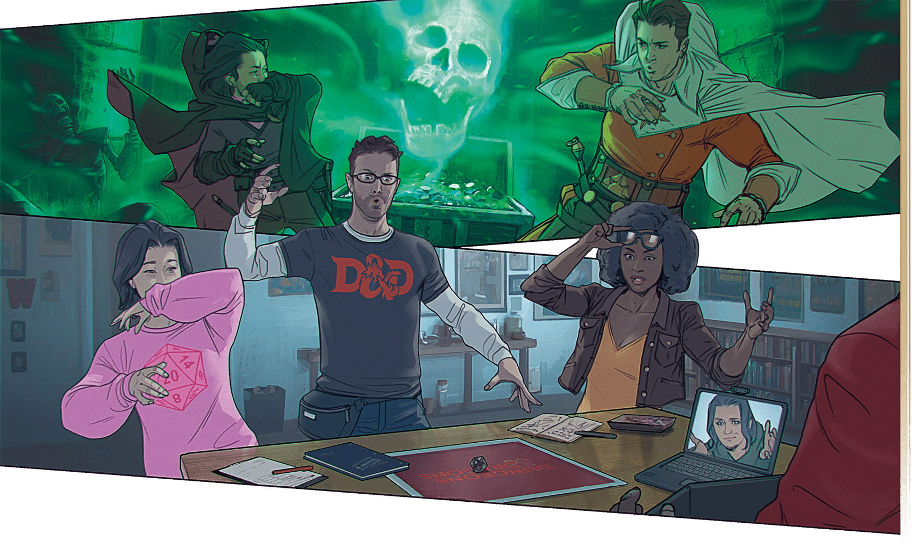](https://media.dndbeyond.com/compendium-images/phb/MKDHZ1nxSXDDLOw2/01-008.exploration-example.png)

*The characters are exploring Castle Ravenloft, and the DM describes the room the characters have entered.*

**Jared (as DM):** A blazing hearth fire fills this room with warm light. Firelight glints off a poker beside the fireplace, and the walls are lined with ancient books. A huge painting hangs above the mantelpiece in a gilded frame. The firelight illuminates the portrait—an exact likeness of Ireena Kolyana.

**Phillip (as Gareth):** How old does the painting look?

**Maeve (as Mirabella):** I’m going to check the books!

**Jared:** OK, I’ll get to those in a second. Russell and Amy, what are your characters doing?

**Russell (as Shreeve):** I stand near the door, sword drawn, ready for danger. This place is creepy!

**Amy (as Auro):** I go near the fireplace. A warm fire sounds nice. But I’m also alert for danger.

**3**

**Jared:** Got it. OK, Phillip, please make an Intelligence (History) check as Gareth looks at the painting.

**Phillip:** I don’t have proficiency in History, but here goes. I got—oh! A 20! For a total of... 20.

**Jared:** Two things leap out at Gareth about the painting. First, the woman’s clothes look old-fashioned. Second, the paint is flaking in places, and the whole thing is covered by a thin layer of soot. You’d say this painting is a few centuries old.

**Everyone Is Accounted For.** Exploration is open-ended; the players don’t take turns moving around the dungeon the way they do in combat. But the DM frequently checks in to make sure it’s clear where everyone is and what they’re doing.

**Teamwork Matters.** The player characters are working toward a common goal. They move together through the dungeon and cooperate to overcome its challenges. When the characters enter the room, they explore different parts of the room. When Auro finds a secret door behind the fireplace later in the example, they come together again to examine it, and Gareth figures out how to bypass the fire. It might seem like Russell’s character wasn’t doing much, but Shreeve was protecting the group by guarding the door.

**3**

**Worth Rolling with or without Proficiency.** You usually have a chance of success on an ability check even if you don’t have proficiency in a relevant skill. In the example, Phillip gets a 20 without proficiency. The d20 brings many surprises to the game—surprises that the DM then interprets.

**Phillip:** So maybe an ancestor of Ireena’s? Unless she’s already a vampire and this “bitten by Strahd” thing is a ruse.

**Jared:** Who knows? Now, Mirabella’s looking at the books?

**Maeve:** Yeah, I pull one off the shelf at random.

**Jared:** It’s a book written in Common called *On the Habitations of the Divine in the Celestial and Infernal Realms*.

**Russell:** Did you just make that up?

**Jared:** I’ll never tell. As you flip through the book, you notice it’s very academic, almost impenetrable.

**Maeve:** OK, I put that one back and pull out another.

**Jared:** Are Shreeve and Auro doing anything else?

**4**

**Amy:** I grab the poker and poke at logs in the fire.

**Jared:** As soon as you lift the poker, you hear a grinding sound, and the back of the fireplace slides to the side, revealing a room behind it!

**Amy:** “Uh, folks? I found something!” Can I see anything in the room beyond?

**4**

**Finding Hidden Objects.** Adventure environments are full of secrets: traps, concealed doors, loose floorboards, and hidden treasures. Characters often use Wisdom checks to find things—see the [**Search**](https://www.dndbeyond.com/sources/dnd/free-rules/rules-glossary#SearchAction) action in the [rules glossary](https://www.dndbeyond.com/sources/dnd/phb-2024/rules-glossary#SearchAction)—but sometimes they stumble on them accidentally, as Auro did here.

**Jared:** Past the flames and smoke, you see a glimmering pile of coins heaped near a chest.

**5**

**Amy:** Anybody have a quick way to put out a fire?

**Phillip:** And you laughed at me for preparing *Create or Destroy Water*! I clutch my Holy Symbol and cast the spell, drenching the fireplace.

**Jared:** What does the spell’s description say?

**Phillip:** It causes 10 gallons of water to rain down in a 30-foot Cube, extinguishing flames there.

**5**

**Casting Spells.** Many characters have the ability to cast spells, which have a huge variety of effects. Some spells are mostly useful in combat, by dealing damage or imposing conditions. Other spells have utility in exploration. If you’re playing a spellcaster, look for a mix of combat-effective and utilitarian spells to help deal with varied challenges.

**Know Your Spells!** Have your *Player’s Handbook* open to the description of a spell before you cast it. Don’t expect the DM to know how your spell works, and be ready to answer any questions about it.

**6**

**Jared:** Great! That puts out the fire. Without the light from the hearth, you’re back to the magic glow of Shreeve’s sword, which casts your shadows into the room beyond. But you can see, through clouds of lingering smoke, a closed chest on the floor, surrounded by piles of coins. There are two torch sconces on the far wall—one holding an unlit torch with an intricate metal base, the other empty. A skeleton in broken plate armor is lying against that wall, with one hand at its throat and the other holding the matching torch from the empty sconce.

**6**

**Vision and Light.** The DM determines what the adventurers can perceive, which means being aware of light sources—like the leaping flames in the fireplace and Shreeve’s glowing sword—as well as obscuring factors like smoke and fog. See “[Vision and Light](https://www.dndbeyond.com/sources/dnd/phb-2024/playing-the-game#VisionandLight)” earlier in this chapter for more information.

**Amy:** I check out the chest!

**Jared:** And the rest of you?

**Phillip:** Gareth enters and looks at the skeleton.

**Maeve:** I keep watch on this side of the fireplace.

**Russell:** I’m still back by the first door.

**Jared:** Amy, the chest seems expertly made, with elegant fittings and clawed feet.

**7**

**Amy:** I try to open it. Is it locked?

**Jared:** It’s not locked and opens easily—and it releases a cloud of sweet-smelling gas.

**Amy:** Oh, no.

**Jared:** Oh, yes. I need Auro and Gareth to make Constitution saving throws.

**Amy:** Sorry, Phillip! I got an 8.

**Phillip:** And a 5 for Gareth.

**Jared:** As you draw this gas into your lungs, you feel a chill grip you, and your bodies stiffen. You both have the Paralyzed condition!

**7**

**Saving Throws.** A saving throw is used to see whether a creature avoids or resists something. When the chest releases toxic gas, Phillip’s and Amy’s characters make Constitution saving throws. Constitution is one of the six abilities that measure creatures’ capabilities, and it has to do with health and stamina. When they fail their saves, the gas causes them to have the [**Paralyzed**](https://www.dndbeyond.com/sources/dnd/free-rules/rules-glossary#ParalyzedCondition) condition. See “[Conditions](https://www.dndbeyond.com/sources/dnd/phb-2024/playing-the-game#Conditions)” later in this chapter for more information.

Combat

**CRAIG J SPEARING**[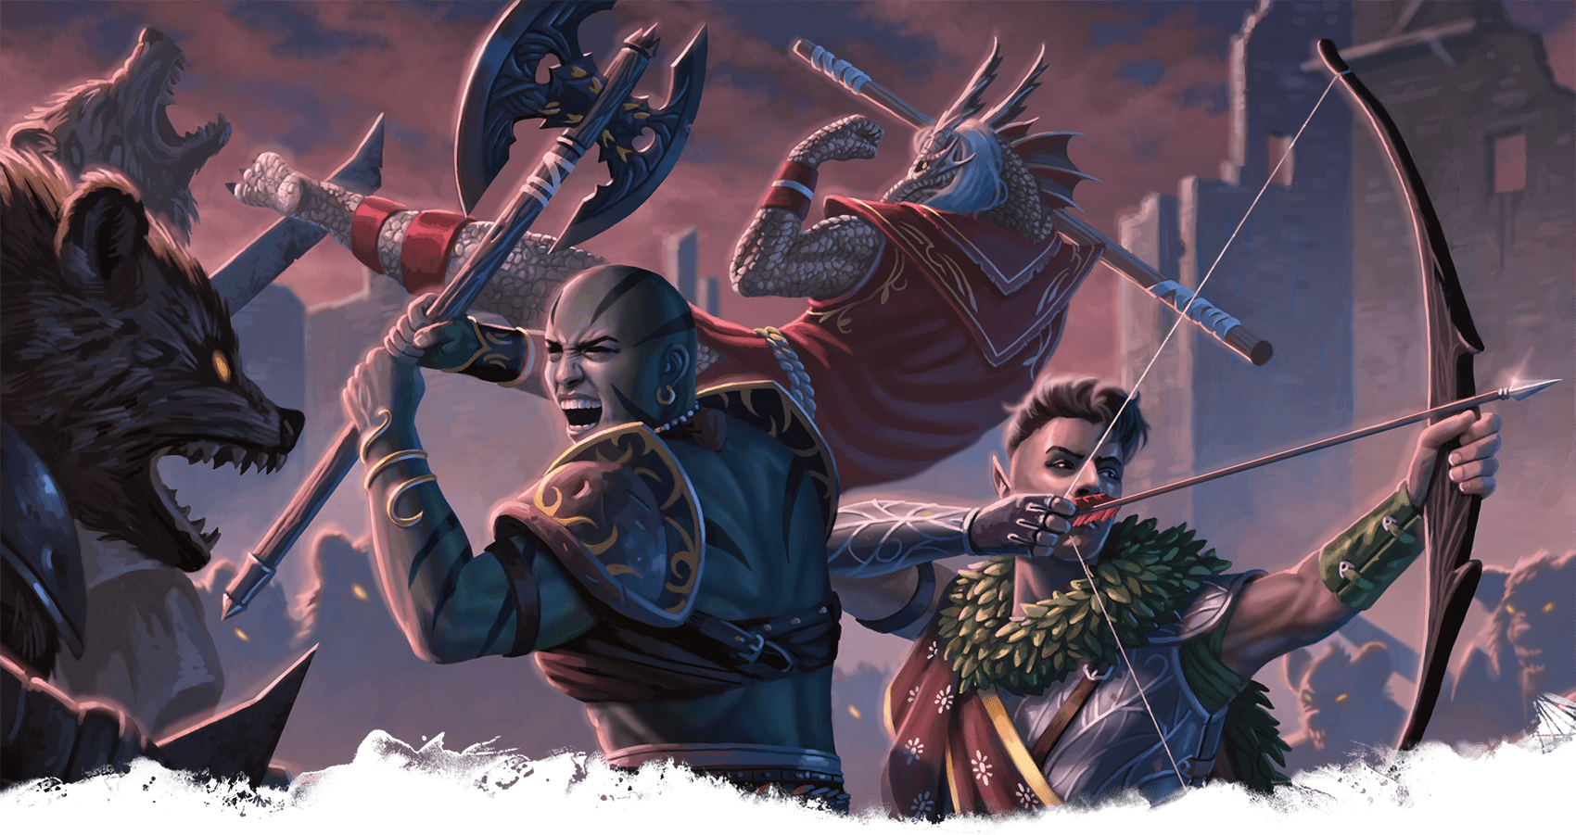](https://media.dndbeyond.com/compendium-images/phb/MKDHZ1nxSXDDLOw2/01-009.adventurers-in-combat.png)

Adventurers encounter many dangerous monsters and nefarious villains. In those moments, combat often breaks out.

The Order of Combat

A typical combat encounter is a clash between two sides: a flurry of weapon swings, feints, parries, footwork, and spellcasting. The game organizes combat into a cycle of rounds and turns. A round represents about 6 seconds in the game world. During a round, each participant in a battle takes a turn. The order of turns is determined at the beginning of combat when everyone rolls [**Initiative**](https://www.dndbeyond.com/sources/dnd/free-rules/rules-glossary#Initiative). Once everyone has taken a turn, the fight continues to the next round if neither side is defeated.

**Combat Step by Step**

Combat unfolds in these steps:

1. **Establish Positions.** The Dungeon Master determines where all the characters and monsters are located. Given the adventurers’ marching order or their stated positions in the room or other location, the DM figures out where the adversaries are—how far away and in what direction.
2. **Roll Initiative.** Everyone involved in the combat encounter rolls [**Initiative**](https://www.dndbeyond.com/sources/dnd/free-rules/rules-glossary#Initiative), determining the order of combatants’ turns.
3. **Take Turns.** Each participant in the battle takes a turn in Initiative order. When everyone involved in the combat has had a turn, the round ends. Repeat this step until the fighting stops.

**Initiative**

Initiative determines the order of turns during combat. When combat starts, every participant rolls Initiative; they make a Dexterity check that determines their place in the Initiative order. The DM rolls for monsters. For a group of identical creatures, the DM makes a single roll, so each member of the group has the same Initiative.

***Surprise.*** If a combatant is surprised by combat starting, that combatant has [**Disadvantage**](https://www.dndbeyond.com/sources/dnd/free-rules/rules-glossary#Disadvantage) on their Initiative roll. For example, if an ambusher starts combat while hidden from a foe who is unaware that combat is starting, that foe is surprised.

***Initiative Order.*** A combatant’s check total is called their Initiative count, or Initiative for short. The DM ranks the combatants, from highest to lowest Initiative. This is the order in which they act during each round. The Initiative order remains the same from round to round.

***Ties.*** If a tie occurs, the DM decides the order among tied monsters, and the players decide the order among tied characters. The DM decides the order if the tie is between a monster and a player character.

**Your Turn**

On your turn, you can move a distance up to your [**Speed**](https://www.dndbeyond.com/sources/dnd/free-rules/rules-glossary#Speed) and take one action. You decide whether to move first or take your action first.

The main actions you can take are listed in “[Actions](https://www.dndbeyond.com/sources/dnd/phb-2024/playing-the-game#Actions)” earlier in this chapter. A character’s features and a monster’s stat block also provide action options. “[Movement and Position](https://www.dndbeyond.com/sources/dnd/phb-2024/playing-the-game#MovementandPosition)” later in this chapter gives the rules for movement.

***Communicating.*** You can communicate however you are able—through brief utterances and gestures—as you take your turn. Doing so uses neither your action nor your move.

Extended communication, such as a detailed explanation of something or an attempt to persuade a foe, requires an action. The Influence action is the main way you try to influence a monster.

***Interacting with Things.*** You can interact with one object or feature of the environment for free, during either your move or action. For example, you could open a door during your move as you stride toward a foe.

If you want to interact with a second object, you need to take the [**Utilize**](https://www.dndbeyond.com/sources/dnd/free-rules/rules-glossary#UtilizeAction) action. Some magic items and other special objects always require an action to use, as stated in their descriptions.

The DM might require you to use an action for any of these activities when it needs special care or when it presents an unusual obstacle. For instance, the DM might require you to take the Utilize action to open a stuck door or turn a crank to lower a drawbridge.

***Doing Nothing on Your Turn.*** You can forgo moving, taking an action, or doing anything at all on your turn. If you can’t decide what to do, consider taking the defensive [**Dodge**](https://www.dndbeyond.com/sources/dnd/free-rules/rules-glossary#DodgeAction) action or the [**Ready**](https://www.dndbeyond.com/sources/dnd/free-rules/rules-glossary#ReadyAction) action to delay acting.

**Ending Combat**

Combat ends when one side or the other is defeated, which can mean the creatures are killed or knocked out or have surrendered or fled. Combat can also end when both sides agree to end it.

Movement and Position

**IGOR GRECHANYI**[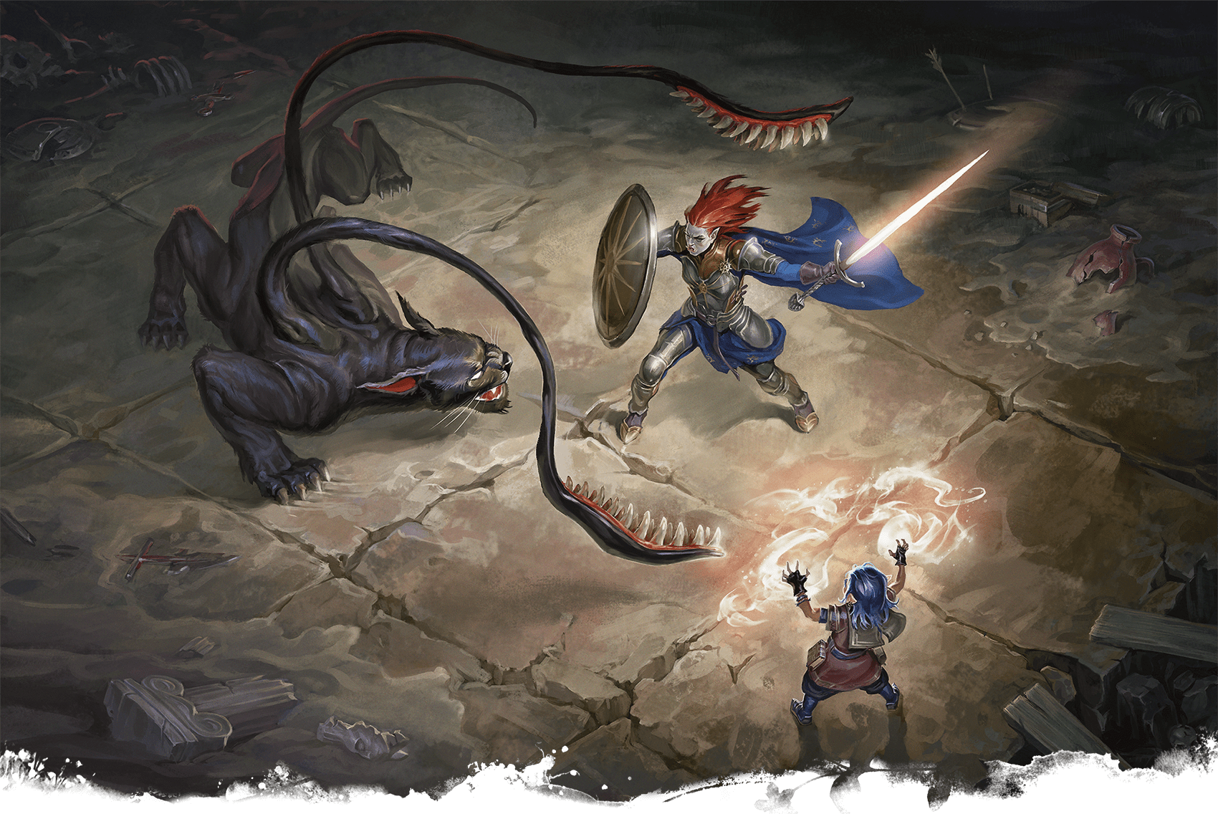](https://media.dndbeyond.com/compendium-images/phb/MKDHZ1nxSXDDLOw2/01-010.displacer-beast-combat.png)Creatures occupy spaces of varying sizes. This Displacer Beast occupies  
a 10-by-10-foot space, while the adventurers occupy 5-by-5-foot spaces

On your turn, you can move a distance equal to your [**Speed**](https://www.dndbeyond.com/sources/dnd/free-rules/rules-glossary#Speed) or less. Or you can decide not to move.

Your movement can include [**climbing**](https://www.dndbeyond.com/sources/dnd/free-rules/rules-glossary#Climbing), [**crawling**](https://www.dndbeyond.com/sources/dnd/free-rules/rules-glossary#Crawling), [**jumping**](https://www.dndbeyond.com/sources/dnd/free-rules/rules-glossary#Jumping), and [**swimming**](https://www.dndbeyond.com/sources/dnd/free-rules/rules-glossary#Swimming) (each explained in the [rules glossary](https://www.dndbeyond.com/sources/dnd/phb-2024/rules-glossary)). These different modes of movement can be combined with your regular movement, or they can constitute your entire move.

However you’re moving with your Speed, you deduct the distance of each part of your move from it until it is used up or until you are done moving, whichever comes first.

A character’s Speed is determined during character creation. A monster’s Speed is noted in the monster’s stat block. See the [rules glossary](https://www.dndbeyond.com/sources/dnd/phb-2024/rules-glossary#Speed) for more about Speed as well as about special speeds, such as a [**Climb Speed**](https://www.dndbeyond.com/sources/dnd/free-rules/rules-glossary#ClimbSpeed), [**Fly Speed**](https://www.dndbeyond.com/sources/dnd/free-rules/rules-glossary#FlySpeed), or [**Swim Speed**](https://www.dndbeyond.com/sources/dnd/free-rules/rules-glossary#SwimSpeed).

**Difficult Terrain**

Combatants are often slowed down by Difficult Terrain. Low furniture, rubble, undergrowth, steep stairs, snow, and shallow bogs are examples of Difficult Terrain.

Every foot of movement in Difficult Terrain costs 1 extra foot, even if multiple things in a space count as Difficult Terrain.

**Playing on a Grid**

If you play using a square grid and miniatures or other tokens, follow these rules.

***Squares.*** Each square represents 5 feet.

***Speed.*** Rather than moving foot by foot, move square by square on the grid, using your Speed in 5-foot segments. You can translate your Speed into squares by dividing it by 5. For example, a Speed of 30 feet translates into 6 squares. If you use a grid often, consider writing your Speed in squares on your character sheet.

***Entering a Square.*** To enter a square, you must have enough movement left to pay for entering. It costs 1 square of movement to enter an unoccupied square that’s adjacent to your space (orthogonally or diagonally adjacent). A square of Difficult Terrain costs 2 squares to enter. Other effects might make a square cost even more.

***Corners.*** Diagonal movement can’t cross the corner of a wall, a large tree, or another terrain feature that fills its space.

***Ranges.*** To determine the range on a grid between two things—whether creatures or objects—count squares from a square adjacent to one of them and stop counting in the space of the other one. Count by the shortest route.

**Breaking Up Your Move**

You can break up your move, using some of its movement before and after any action, Bonus Action, or Reaction you take on the same turn. For example, if you have a Speed of 30 feet, you could go 10 feet, take an action, and then go 20 feet.

**Dropping Prone**

On your turn, you can give yourself the [**Prone**](https://www.dndbeyond.com/sources/dnd/free-rules/rules-glossary#ProneCondition) condition (see the [rules glossary](https://www.dndbeyond.com/sources/dnd/phb-2024/rules-glossary#ProneCondition)) without using an action or any of your Speed, but you can’t do so if your Speed is 0.

**Creature Size**

A creature belongs to a size category, which determines the width of the square space the creature occupies on a map, as shown on the Creature Size and Space table. That table lists the sizes from smallest (Tiny) to largest (Gargantuan). A creature’s space is the area that it effectively controls in combat and the area it needs to fight effectively.

A character’s size is determined by species, and a monster’s size is specified in the monster’s stat block.

| **Creature Size and Space** | | |
| --- | --- | --- |
| **Size** | **Space (Feet)** | **Space (Squares)** |
| Tiny | 2½ by 2½ feet | 4 per square |
| Small | 5 by 5 feet | 1 square |
| Medium | 5 by 5 feet | 1 square |
| Large | 10 by 10 feet | 4 squares (2 by 2) |
| Huge | 15 by 15 feet | 9 squares (3 by 3) |
| Gargantuan | 20 by 20 feet | 16 squares (4 by 4) |

**Moving around Other Creatures**

During your move, you can pass through the space of an ally, a creature that has the [**Incapacitated**](https://www.dndbeyond.com/sources/dnd/free-rules/rules-glossary#IncapacitatedCondition) condition (see the [rules glossary](https://www.dndbeyond.com/sources/dnd/phb-2024/rules-glossary#IncapacitatedCondition)), a Tiny creature, or a creature that is two sizes larger or smaller than you.

Another creature’s space is [**Difficult Terrain**](https://www.dndbeyond.com/sources/dnd/free-rules/rules-glossary#DifficultTerrain) for you unless that creature is Tiny or your ally.

You can’t willingly end a move in a space occupied by another creature. If you somehow end a turn in a space with another creature, you have the [**Prone**](https://www.dndbeyond.com/sources/dnd/free-rules/rules-glossary#ProneCondition) condition (see the [rules glossary](https://www.dndbeyond.com/sources/dnd/phb-2024/rules-glossary#ProneCondition)) unless you are Tiny or are of a larger size than the other creature.

Making an Attack

When you take the [**Attack**](https://www.dndbeyond.com/sources/dnd/free-rules/rules-glossary#AttackAction) action, you make an attack. Some other actions, Bonus Actions, and Reactions also let you make an attack. Whether you strike with a Melee weapon, fire a Ranged weapon, or make an attack roll as part of a spell, an attack has the following structure:

1. **Choose a Target.** Pick a target within your attack’s range: a creature, an object, or a location.
2. **Determine Modifiers.** The DM determines whether the target has [**Cover**](https://www.dndbeyond.com/sources/dnd/free-rules/rules-glossary#Cover) (see the next section) and whether you have [**Advantage**](https://www.dndbeyond.com/sources/dnd/free-rules/rules-glossary#Advantage) or [**Disadvantage**](https://www.dndbeyond.com/sources/dnd/free-rules/rules-glossary#Disadvantage) against the target. In addition, spells, special abilities, and other effects can apply penalties or bonuses to your attack roll.
3. **Resolve the Attack.** Make the attack roll, as detailed earlier in this chapter. On a hit, you roll damage unless the particular attack has rules that specify otherwise. Some attacks cause special effects in addition to or instead of damage.

Cover

Walls, trees, creatures, and other obstacles can provide cover, making a target more difficult to harm. As detailed in the Cover table, there are three degrees of cover, each of which gives a different benefit to a target.

A target can benefit from cover only when an attack or other effect originates on the opposite side of the cover. If a target is behind multiple sources of cover, only the most protective degree of cover applies; the degrees aren’t added together. For example, if a target is behind a creature that gives [**Half Cover**](https://www.dndbeyond.com/sources/dnd/free-rules/rules-glossary#Cover) and a tree trunk that gives [**Three-Quarters Cover**](https://www.dndbeyond.com/sources/dnd/free-rules/rules-glossary#Cover), the target has Three-Quarters Cover.

| **Cover** | | |
| --- | --- | --- |
| **Degree** | **Benefit to Target** | **Offered By...** |
| [**Half**](https://www.dndbeyond.com/sources/dnd/free-rules/rules-glossary#Cover) | +2 bonus to AC and Dexterity saving throws | Another creature or an object that covers at least half of the target |
| [**Three-Quarters**](https://www.dndbeyond.com/sources/dnd/free-rules/rules-glossary#Cover) | +5 bonus to AC and Dexterity saving throws | An object that covers at least three-quarters of the target |
| [**Total**](https://www.dndbeyond.com/sources/dnd/free-rules/rules-glossary#Cover) | Can’t be targeted directly | An object that covers the whole target |

**Unseen Attackers and Targets**

When you make an attack roll against a target you can’t see, you have [**Disadvantage**](https://www.dndbeyond.com/sources/dnd/free-rules/rules-glossary#Disadvantage) on the roll. This is true whether you’re guessing the target’s location or targeting a creature you can hear but not see. If the target isn’t in the location you targeted, you miss.

When a creature can’t see you, you have [**Advantage**](https://www.dndbeyond.com/sources/dnd/free-rules/rules-glossary#Advantage) on attack rolls against it.

If you are hidden when you make an attack roll, you give away your location when the attack hits or misses.

Ranged Attacks

When you make a ranged attack, you fire a bow, hurl an axe, or otherwise send projectiles to strike a foe at a distance. Many spells also involve making a ranged attack.

**Range**

You can make ranged attacks only against targets within a specified range. If a ranged attack, such as one made with a spell, has a single range, you can’t attack a target beyond this range.

Some ranged attacks, such as those made with a [**Longbow**](https://www.dndbeyond.com/equipment/37-longbow), have two ranges. The smaller number is the normal range, and the larger number is the long range. Your attack roll has [**Disadvantage**](https://www.dndbeyond.com/sources/dnd/free-rules/rules-glossary#Disadvantage) when your target is beyond normal range, and you can’t attack a target beyond long range.

**Ranged Attacks in Close Combat**

Aiming a ranged attack is more difficult when a foe is next to you. When you make a ranged attack roll with a weapon, a spell, or some other means, you have [**Disadvantage**](https://www.dndbeyond.com/sources/dnd/free-rules/rules-glossary#Disadvantage) on the roll if you are within 5 feet of an enemy who can see you and doesn’t have the [**Incapacitated**](https://www.dndbeyond.com/sources/dnd/free-rules/rules-glossary#IncapacitatedCondition) condition (see the [rules glossary](https://www.dndbeyond.com/sources/dnd/phb-2024/rules-glossary#IncapacitatedCondition)).

Melee Attacks

A melee attack allows you to attack a target within your reach. A melee attack typically uses a handheld weapon or an [**Unarmed Strike**](https://www.dndbeyond.com/sources/dnd/free-rules/rules-glossary#UnarmedStrike). Many monsters make melee attacks with claws, teeth, or other body parts. A few spells also involve melee attacks.

**Reach**

A creature has a 5-foot reach and can thus attack targets within 5 feet when making a melee attack. Certain creatures have melee attacks with a reach greater than 5 feet, as noted in their descriptions.

**Opportunity Attacks**

Combatants watch for enemies to drop their guard. If you move heedlessly past your foes, you put yourself in danger by provoking an Opportunity Attack.

***Avoiding Opportunity Attacks.*** You can avoid provoking an Opportunity Attack by taking the [**Disengage**](https://www.dndbeyond.com/sources/dnd/free-rules/rules-glossary#DisengageAction) action. You also don’t provoke an Opportunity Attack when you [**teleport**](https://www.dndbeyond.com/sources/dnd/free-rules/rules-glossary#Teleportation) or when you are moved without using your movement, action, Bonus Action, or Reaction. For example, you don’t provoke an Opportunity Attack if an explosion hurls you out of a foe’s reach or if you fall past an enemy.

***Making an Opportunity Attack.*** You can make an Opportunity Attack when a creature that you can see leaves your reach. To make the attack, take a Reaction to make one melee attack with a weapon or an [**Unarmed Strike**](https://www.dndbeyond.com/sources/dnd/free-rules/rules-glossary#UnarmedStrike) against that creature. The attack occurs right before it leaves your reach.

Mounted Combat

**GABOLEPS**[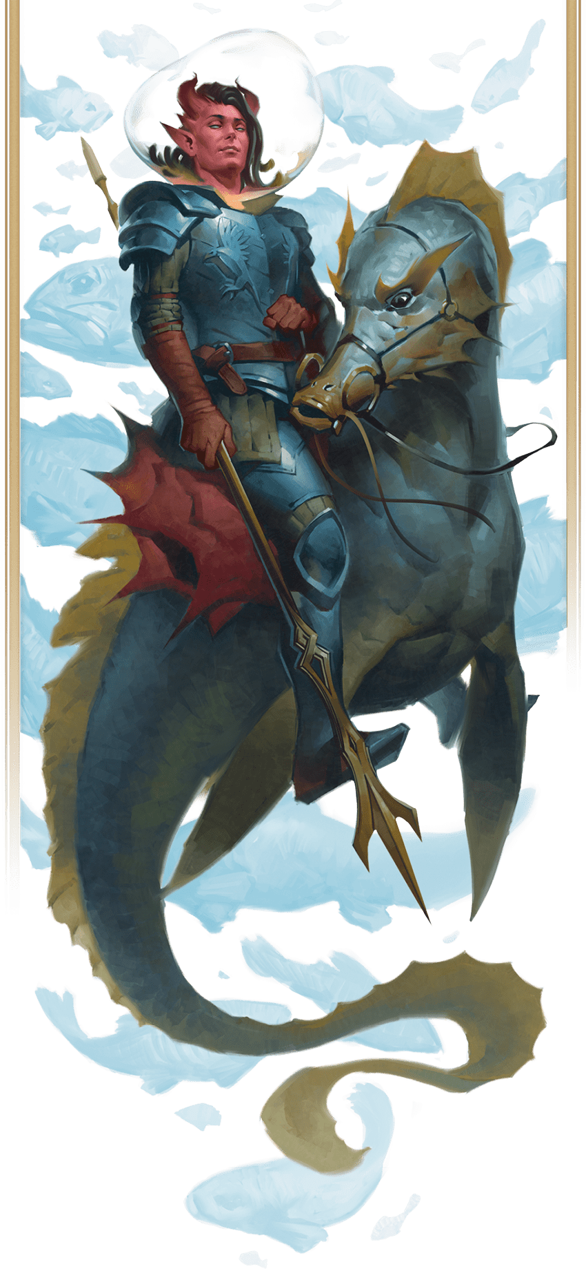](https://media.dndbeyond.com/compendium-images/phb/MKDHZ1nxSXDDLOw2/01-011.giant-seahorse-mount.png)Astride a giant seahorse, a  
paladin adventures underwater

A willing creature that is at least one size larger than a rider and that has an appropriate anatomy can serve as a mount, using the following rules.

**Mounting and Dismounting**

During your move, you can mount a creature that is within 5 feet of you or dismount. Doing so costs an amount of movement equal to half your [**Speed**](https://www.dndbeyond.com/sources/dnd/free-rules/rules-glossary#Speed) (round down). For example, if your Speed is 30 feet, you spend 15 feet of movement to mount a horse.

**Controlling a Mount**

You can control a mount only if it has been trained to accept a rider. Domesticated horses, mules, and similar creatures have such training.

The [**Initiative**](https://www.dndbeyond.com/sources/dnd/free-rules/rules-glossary#Initiative) of a controlled mount changes to match yours when you mount it. It moves on your turn as you direct it, and it has only three action options during that turn: [**Dash**](https://www.dndbeyond.com/sources/dnd/free-rules/rules-glossary#DashAction), [**Disengage**](https://www.dndbeyond.com/sources/dnd/free-rules/rules-glossary#DisengageAction), and [**Dodge**](https://www.dndbeyond.com/sources/dnd/free-rules/rules-glossary#DodgeAction). A controlled mount can move and act even on the turn that you mount it.

In contrast, an independent mount—one that lets you ride but ignores your control—retains its place in the Initiative order and moves and acts as it likes.

**Falling Off**

If an effect is about to move your mount against its will while you’re on it, you must succeed on a DC 10 Dexterity saving throw or fall off, landing with the [**Prone**](https://www.dndbeyond.com/sources/dnd/free-rules/rules-glossary#ProneCondition) condition (see the [rules glossary](https://www.dndbeyond.com/sources/dnd/phb-2024/rules-glossary#ProneCondition)) in an unoccupied space within 5 feet of the mount.

While mounted, you must make the same save if you’re knocked [**Prone**](https://www.dndbeyond.com/sources/dnd/free-rules/rules-glossary#ProneCondition) or the mount is.

Underwater Combat

A fight underwater follows these rules.

**Impeded Weapons**

When making a melee attack roll with a weapon underwater, a creature that lacks a [**Swim Speed**](https://www.dndbeyond.com/sources/dnd/free-rules/rules-glossary#SwimSpeed) has [**Disadvantage**](https://www.dndbeyond.com/sources/dnd/free-rules/rules-glossary#Disadvantage) on the attack roll unless the weapon deals Piercing damage.

A ranged attack roll with a weapon underwater automatically misses a target beyond the weapon’s normal range, and the attack roll has Disadvantage against a target within normal range.

**Fire Resistance**

Anything underwater has Resistance to Fire damage (explained in “Damage and Healing”).

Damage and Healing

Injury and death are frequent threats in D&D, as detailed in the following rules.

Hit Points

Hit Points represent durability and the will to live. Creatures with more Hit Points are more difficult to kill. Your Hit Point maximum is the number of Hit Points you have when uninjured. Your current Hit Points can be any number from that maximum down to 0, which is the lowest Hit Points can go.

Whenever you take damage, subtract it from your Hit Points. Hit Point loss has no effect on your capabilities until you reach 0 Hit Points.

If you have half your Hit Points or fewer, you’re Bloodied, which has no game effect on its own but which might trigger other game effects.

**Resting**

Adventurers can’t spend every hour adventuring. They need rest. Any creature can take hour-long [**Short Rests**](https://www.dndbeyond.com/sources/dnd/free-rules/rules-glossary#ShortRest) in the midst of a day and an 8-hour [**Long Rest**](https://www.dndbeyond.com/sources/dnd/free-rules/rules-glossary#LongRest) to end it. Regaining Hit Points is one of the main benefits of a rest. The [rules glossary](https://www.dndbeyond.com/sources/dnd/phb-2024/rules-glossary) provides the rules for Short and Long Rests.

Damage Rolls

Each weapon, spell, and damaging monster ability specifies the damage it deals. You roll the damage dice, add any modifiers, and deal the damage to your target. If there’s a penalty to the damage, it’s possible to deal 0 damage but not negative damage.

When attacking with a weapon, you add your ability modifier—the same modifier used for the attack roll—to the damage roll. A spell tells you which dice to roll for damage and whether to add any modifiers. Unless a rule says otherwise, you don’t add your ability modifier to a fixed damage amount that doesn’t use a roll, such as the damage of a [**Blowgun**](https://www.dndbeyond.com/equipment/35-blowgun). See [chapter 6](https://www.dndbeyond.com/sources/dnd/phb-2024/equipment#Weapons) for weapons’ damage dice and [chapter 7](https://www.dndbeyond.com/sources/dnd/phb-2024/spells) for spells’ damage dice.

Critical Hits

When you score a Critical Hit, you deal extra damage. Roll the attack’s damage dice twice, add them together, and add any relevant modifiers as normal. For example, if you score a Critical Hit with a [**Dagger**](https://www.dndbeyond.com/equipment/3-dagger), roll 2d4 for the damage rather than 1d4, and add your relevant ability modifier. If the attack involves other damage dice, such as from the Rogue’s Sneak Attack feature, you also roll those dice twice.

Saving Throws and Damage

Damage dealt via saving throws uses these rules.

**Damage against Multiple Targets**

When you create a damaging effect that forces two or more targets to make saving throws against it at the same time, roll the damage once for all the targets. For example, when a wizard casts [***Fireball***](https://www.dndbeyond.com/spells/2618887-fireball), the spell’s damage is rolled once for all creatures caught in the blast.

**Half Damage**

Many saving throw effects deal half damage (round down) to a target when the target succeeds on the saving throw. The halved damage is equal to half the damage that would be dealt on a failed save.

Damage Types

Each instance of damage has a type, like Fire or Slashing. Damage types are listed in the [rules glossary](https://www.dndbeyond.com/sources/dnd/phb-2024/rules-glossary#DamageTypes) and have no rules of their own, but other rules, such as [**Resistance**](https://www.dndbeyond.com/sources/dnd/free-rules/rules-glossary#Resistance), rely on damage types.

Resistance and Vulnerability

Some creatures and objects have Resistance or Vulnerability to certain damage types. If you have Resistance to a damage type, damage of that type is halved against you (round down). If you have Vulnerability to a damage type, damage of that type is doubled against you. For example, if you have Resistance to Cold damage, such damage is halved against you, and if you have Vulnerability to Fire damage, such damage is doubled against you.

**No Stacking**

Multiple instances of Resistance or Vulnerability that affect the same damage type count as only one instance. For example, if you have Resistance to Necrotic damage as well as Resistance to all damage, Necrotic damage is reduced by half against you.

**Order of Application**

Modifiers to damage are applied in the following order: adjustments such as bonuses, penalties, or multipliers are applied first; Resistance is applied second; and Vulnerability is applied third.

For example, a creature has Resistance to all damage and Vulnerability to Fire damage, and it’s within a magical aura that reduces all damage by 5. If it takes 28 Fire damage, the damage is first reduced by 5 (to 23), then halved for the creature’s Resistance (and rounded down to 11), then doubled for its Vulnerability (to 22).

Immunity

Some creatures and objects have Immunity to certain damage types and conditions. Immunity to a damage type means you don’t take damage of that type, and Immunity to a condition means you aren’t affected by it.

Healing

Hit Points can be restored by magic, such as the [***Cure Wounds***](https://www.dndbeyond.com/spells/2619079-cure-wounds) spell or a [***Potion of Healing***](https://www.dndbeyond.com/magic-items/8960641-potion-of-healing), or by a [**Short**](https://www.dndbeyond.com/sources/dnd/free-rules/rules-glossary#ShortRest) or [**Long Rest**](https://www.dndbeyond.com/sources/dnd/free-rules/rules-glossary#LongRest) (see the [rules glossary](https://www.dndbeyond.com/sources/dnd/phb-2024/rules-glossary)).

When you receive healing, add the restored Hit Points to your current Hit Points. Your Hit Points can’t exceed your Hit Point maximum, so any Hit Points regained in excess of the maximum are lost. For example, if you receive 8 Hit Points of healing and have 14 Hit Points and a Hit Point maximum of 20, you regain 6 Hit Points, not 8.

Dropping to 0 Hit Points

When a creature drops to 0 Hit Points, it either dies outright or falls [**unconscious**](https://www.dndbeyond.com/sources/dnd/free-rules/rules-glossary#UnconsciousCondition), as explained below.

**Instant Death**

Here are the main ways a creature can die instantly.

***Monster Death.*** A monster dies the instant it drops to 0 Hit Points, although a Dungeon Master can ignore this rule for an individual monster and treat it like a character.

***Hit Point Maximum of 0.*** A creature dies if its Hit Point maximum reaches 0. Certain effects drain life energy, reducing a creature’s Hit Point maximum.

***Massive Damage.*** When damage reduces a character to 0 Hit Points and damage remains, the character dies if the remainder equals or exceeds their Hit Point maximum. For example, if your character has a Hit Point maximum of 12, currently has 6 Hit Points, and takes 18 damage, the character drops to 0 Hit Points, but 12 damage remains. The character then dies, since 12 equals their Hit Point maximum.

**Character Demise**

If your character dies, others might find a magical way to revive your character, such as with the [***Raise Dead***](https://www.dndbeyond.com/spells/2618922-raise-dead) spell. Or talk with the DM about making a new character to join the group. The [rules glossary](https://www.dndbeyond.com/sources/dnd/phb-2024/rules-glossary#Dead) has more information on being [**dead**](https://www.dndbeyond.com/sources/dnd/free-rules/rules-glossary#Dead).

**Falling Unconscious**

If you reach 0 Hit Points and don’t die instantly, you have the [**Unconscious**](https://www.dndbeyond.com/sources/dnd/free-rules/rules-glossary#UnconsciousCondition) condition (see the [rules glossary](https://www.dndbeyond.com/sources/dnd/phb-2024/rules-glossary#UnconsciousCondition)) until you regain any Hit Points, and you now face making [**Death Saving Throws**](https://www.dndbeyond.com/sources/dnd/free-rules/rules-glossary#DeathSavingThrow) (see below).

**Knocking Out a Creature**

When you would reduce a creature to 0 Hit Points with a melee attack, you can instead reduce the creature to 1 Hit Point and give it the [**Unconscious**](https://www.dndbeyond.com/sources/dnd/free-rules/rules-glossary#UnconsciousCondition) condition. It then starts a [**Short Rest**](https://www.dndbeyond.com/sources/dnd/free-rules/rules-glossary#ShortRest), at the end of which that condition ends on it. The condition ends early if the creature regains any Hit Points or if someone takes an action to administer first aid to it, making a successful DC 10 Wisdom ([**Medicine**](https://www.dndbeyond.com/sources/dnd/free-rules/playing-the-game#Skills)) check.

**Death Saving Throws**

Whenever you start your turn with 0 Hit Points, you must make a Death Saving Throw to determine whether you creep closer to death or hang on to life. Unlike other saving throws, this one isn’t tied to an ability score. You’re in the hands of fate now.

***Three Successes/Failures.*** Roll 1d20. If the roll is 10 or higher, you succeed. Otherwise, you fail. A success or failure has no effect by itself. On your third success, you become [**Stable**](https://www.dndbeyond.com/sources/dnd/free-rules/rules-glossary#Stable) (see “Stabilizing a Character” below). On your third failure, you die.

The successes and failures don’t need to be consecutive; keep track of both until you collect three of a kind. The number of both is reset to zero when you regain any Hit Points or become Stable.

***Rolling a 1 or 20.*** When you roll a 1 on the d20 for a Death Saving Throw, you suffer two failures. If you roll a 20 on the d20, you regain 1 Hit Point.

***Damage at 0 Hit Points.*** If you take any damage while you have 0 Hit Points, you suffer a Death Saving Throw failure. If the damage is from a Critical Hit, you suffer two failures instead. If the damage equals or exceeds your Hit Point maximum, you die.

**Stabilizing a Character**

You can take the [**Help**](https://www.dndbeyond.com/sources/dnd/free-rules/rules-glossary#HelpAction) action to try to stabilize a creature with 0 Hit Points, which requires a successful DC 10 Wisdom ([**Medicine**](https://www.dndbeyond.com/sources/dnd/free-rules/playing-the-game#Skills)) check.

A Stable creature doesn’t make Death Saving Throws even though it has 0 Hit Points, but it still has the [**Unconscious**](https://www.dndbeyond.com/sources/dnd/free-rules/rules-glossary#UnconsciousCondition) condition. If the creature takes damage, it stops being Stable and starts making Death Saving Throws again. A Stable creature that isn’t healed regains 1 Hit Point after 1d4 hours.

Temporary Hit Points

Some spells and other effects confer Temporary Hit Points, which are a buffer against losing actual Hit Points, as explained below.

**Lose Temporary Hit Points First**

If you have Temporary Hit Points and take damage, those points are lost first, and any leftover damage carries over to your Hit Points. For example, if you have 5 Temporary Hit Points and take 7 damage, you lose those points and then lose 2 Hit Points.

**Duration**

Temporary Hit Points last until they’re depleted or you finish a [**Long Rest**](https://www.dndbeyond.com/sources/dnd/free-rules/rules-glossary#LongRest) (see the [rules glossary](https://www.dndbeyond.com/sources/dnd/phb-2024/rules-glossary#LongRest)).

**Temporary Hit Points Don’t Stack**

Temporary Hit Points can’t be added together. If you have Temporary Hit Points and receive more of them, you decide whether to keep the ones you have or to gain the new ones. For example, if a spell grants you 12 Temporary Hit Points when you already have 10, you can have 12 or 10, not 22.

**They’re Not Hit Points or Healing**

Temporary Hit Points can’t be added to your Hit Points, healing can’t restore them, and receiving Temporary Hit Points doesn’t count as healing. Because Temporary Hit Points aren’t Hit Points, a creature can be at full Hit Points and receive Temporary Hit Points.

If you have 0 Hit Points, receiving Temporary Hit Points doesn’t restore you to consciousness. Only true healing can save you.

Conditions

Many effects impose a condition, a temporary state that alters the recipient’s capabilities. The following conditions are defined in the [rules glossary](https://www.dndbeyond.com/sources/dnd/phb-2024/rules-glossary):

* [**Blinded**](https://www.dndbeyond.com/sources/dnd/free-rules/rules-glossary#BlindedCondition)
* [**Charmed**](https://www.dndbeyond.com/sources/dnd/free-rules/rules-glossary#CharmedCondition)
* [**Deafened**](https://www.dndbeyond.com/sources/dnd/free-rules/rules-glossary#DeafenedCondition)
* [**Exhaustion**](https://www.dndbeyond.com/sources/dnd/free-rules/rules-glossary#ExhaustionCondition)
* [**Frightened**](https://www.dndbeyond.com/sources/dnd/free-rules/rules-glossary#FrightenedCondition)
* [**Grappled**](https://www.dndbeyond.com/sources/dnd/free-rules/rules-glossary#GrappledCondition)
* [**Incapacitated**](https://www.dndbeyond.com/sources/dnd/free-rules/rules-glossary#IncapacitatedCondition)
* [**Invisible**](https://www.dndbeyond.com/sources/dnd/free-rules/rules-glossary#InvisibleCondition)
* [**Paralyzed**](https://www.dndbeyond.com/sources/dnd/free-rules/rules-glossary#ParalyzedCondition)
* [**Petrified**](https://www.dndbeyond.com/sources/dnd/free-rules/rules-glossary#PetrifiedCondition)
* [**Poisoned**](https://www.dndbeyond.com/sources/dnd/free-rules/rules-glossary#PoisonedCondition)
* [**Prone**](https://www.dndbeyond.com/sources/dnd/free-rules/rules-glossary#ProneCondition)
* [**Restrained**](https://www.dndbeyond.com/sources/dnd/free-rules/rules-glossary#RestrainedCondition)
* [**Stunned**](https://www.dndbeyond.com/sources/dnd/free-rules/rules-glossary#StunnedCondition)
* [**Unconscious**](https://www.dndbeyond.com/sources/dnd/free-rules/rules-glossary#UnconsciousCondition)

The definition of a condition specifies what happens to its recipient while affected by it, and some conditions apply other conditions.

Duration

A condition lasts either for a duration specified by the effect that imposed the condition or until the condition is countered (the [**Prone**](https://www.dndbeyond.com/sources/dnd/free-rules/rules-glossary#ProneCondition) condition is countered by standing up, for example).

Conditions Don’t Stack

If multiple effects impose the same condition on you, each instance of the condition has its own duration, but the condition’s effects don’t get worse. Either you have a condition or you don’t. The [**Exhaustion**](https://www.dndbeyond.com/sources/dnd/free-rules/rules-glossary#ExhaustionCondition) condition is an exception; its effects get worse if you have the condition and receive it again.

Combat and Damage Example

In this scene, threats force a group of adventurers into battle. This example demonstrates the turn-based flow of combat that gives each player a chance to detail what they do during the high-stakes moments of a fight.

*Below Castle Ravenloft, the characters enter combat!*

**Jared (as DM):** Yellow lichen covers the ceiling in this passage, which has alcoves along both sides.

**Russell (as Shreeve):** I peer into the nearest alcoves.

**8**

**Jared:** They each contain human skeletal remains. The silence is broken suddenly by the rattle of bones as the skeletons lurch to their feet all around you and prepare to attack!

**8**

**Starting Combat.** While describing the skeletons animating, the DM gets ready to start combat by mentally figuring out where everyone is, referring to the map of the area and the party’s established marching order.

**Russell:** Ack! How many skeletons?

**9**

**Jared:** Ten in all, and they’re hostile. Roll Initiative!

**Russell:** Ten skeletons? Yikes! I got a 16.

**Maeve (as Mirabella):** I got 8.

**9**

**Rolling Initiative.** The next step in combat is for everyone involved to roll [**Initiative**](https://www.dndbeyond.com/sources/dnd/free-rules/rules-glossary#Initiative).

**Phillip (as Gareth):** An incredible 2 for Gareth.

**Amy (as Auro):** I got a 19!

**10**

**Jared:** The Rogue is quick to react—but not as quick as the skeletons! They got a 20. The first four attack the person in the lead: Shreeve.

**10**

**Taking Turns.** Now each participant in the battle takes a turn in Initiative order. The skeletons go first because they got the highest Initiative: 20.

**Russell:** Oh, boy.

**11**

**Jared:** Their attack roll totals are 8, 16, 18, and 20.

**Russell:** The 8 and 16 miss my AC, but the others hit.

**Jared:** Two of them stick you with their broken blades, dealing a total of 9 Piercing damage.

**11**

**Attack Rolls.** When a creature attacks, whether swinging a sword or firing an arrow from a bow, its player makes an attack roll. If the total is equal to or higher than the target’s [**Armor Class**](https://www.dndbeyond.com/sources/dnd/free-rules/rules-glossary#ArmorClass) (AC), the attack hits.

**Russell:** Is that the best you can do?

**Phillip:** Never say that to the DM.

**Jared:** Heh. Now two of them attack Auro. The first roll is a natural 1: a miss. The second roll is 16.

**Amy:** That hits.

**Jared:** You take 4 Piercing damage, and one of them attacks Mirabella with a roll of 14.

**12**

**Maeve:** Hits. No, wait! I cast *Shield*, so that misses.

**Jared:** The skeleton’s blade bounces off your shield of magical force. Then two of them attack Gareth. One misses with a 5, but the other one lands a solid blow with a 21, dealing 7 piercing damage.

**12**

**Spells and Reactions.** Mirabella casts the [***Shield***](https://www.dndbeyond.com/spells/2619019-shield) spell. It’s a special property of this spell that it can be cast even when it’s not the caster’s turn, using her Reaction (see “[Actions](https://www.dndbeyond.com/sources/dnd/phb-2024/playing-the-game#Reactions)” earlier in this chapter).

**Phillip:** That got my attention!

**Jared:** That’s nine attacks. There’s one more skeleton at the end of the hall. It moves up and waits for an opening. Now it’s Auro’s turn.

**Amy:** I attack one close to me. Does a 24 hit?

**Jared:** A solid hit!

**Amy:** And it’s next to one of my allies, right?

**Jared:** Yes.

**13**

**Amy:** So with my Sneak Attack, that’s 22 damage!

**Jared:** Your blade slides into an empty eye socket, and the skeleton clatters to the ground, now inanimate and harmless.

**13**

**Amy:** Then I use Cunning Action to Disengage as a Bonus Action and move 20 feet out of the melee.

**13**

**Special Abilities.** Auro’s Sneak Attack lets him deal extra damage to the skeletons, and his Cunning Action lets him [**Disengage**](https://www.dndbeyond.com/sources/dnd/free-rules/rules-glossary#DisengageAction) as a Bonus Action. These are examples of class features (described in [chapter 3](https://www.dndbeyond.com/sources/dnd/phb-2024/character-classes)) that let characters bend the rules.

**Jared:** Very good. Shreeve?

**14**

**Russell:** I drop my sword and pull out my warhammer. Time to break some bones! My first attack is a 21 to hit for 7 Bludgeoning damage.

**Jared:** It tries to block your swing, but the force of your blow destroys the skeleton!

**14**

**Vulnerability.** An attack that deals Bludgeoning damage is deadly to skeletons. Shreeve knows this from past experience, which is why she drops her sword and switches to a Bludgeoning weapon. She rolls only 7 damage, but the DM knows the skeleton actually takes 14 damage.

**Russell:** I swing at the next skeleton with 11 to hit.

**Jared:** The skeleton dodges out of the way.

**Russell:** Rats. That’s my turn.

**Jared:** Mirabella?

**15**

**Maeve:** How many can I get in a 15-foot Cube?

**Jared:** Three if you don’t want to get Shreeve too.

**15**

**Areas of Effect.** Spells and many other effects in the game fill a specific area that is defined by the rules, like the 15-foot [**Cube**](https://www.dndbeyond.com/sources/dnd/free-rules/rules-glossary#CubeAreaofEffect) of the [***Thunderwave***](https://www.dndbeyond.com/spells/2619184-thunderwave) spell. See the [rules glossary](https://www.dndbeyond.com/sources/dnd/phb-2024/rules-glossary#AreaofEffect) for more on areas of effect.

**16**

**Maeve:** That’s probably best. I cast *Thunderwave* at those three, using a level 2 spell slot. So there’s a loud boom, and a wave of thunderous force sweeps over the skeletons. They need to make DC 15 Constitution saves.

**Jared:** They all fail!

**16**

**Saving Throws.** The skeletons make Constitution saving throws to resist the [***Thunderwave***](https://www.dndbeyond.com/spells/2619184-thunderwave) spell. When they fail those saves, they take damage and are pushed, as defined in that spell’s description.

**Maeve:** Because I used a level 2 slot, that’s 15 Thunder damage, and they’re pushed 10 feet away.

**Jared:** They’re pushed back and shattered.

**Maeve:** Excellent! Four down, six to go.

**Jared:** And it’s Gareth’s turn at last!

**Phillip:** How many of them are within 30 feet of me?

**Damage and Hit Points.** The skeletons have 13 Hit Points each, so the spells and attacks in this example deal enough damage to destroy them. If a spell or an attack dealt less than 13 damage, the DM would keep track of the damage each skeleton has taken until it is reduced to 0 Hit Points and is destroyed.

**Jared:** All six.

**17**

**Phillip:** I hold up my Holy Symbol and ask Pelor the Holy Sun to sear these skeletons. They need to make DC 15 Wisdom saves.

**Jared (rolling):** Oh, those are not good numbers. None of them even got close.

**Phillip:** They each take 18 Radiant damage and—

**17**

**Saving Throws.** Gareth’s Sear Undead is a class feature (see [chapter 3](https://www.dndbeyond.com/sources/dnd/phb-2024/character-classes)). As with Mirabella’s [***Thunderwave***](https://www.dndbeyond.com/spells/2619184-thunderwave) spell, Sear Undead forces the skeletons to make a saving throw.

**Jared:** Never mind the “and.” Pelor does indeed smite these skeletons! They’re silhouetted for a moment in a burst of brilliant light, then they vanish, leaving only their broken swords behind.

**JOHN GRELLO**[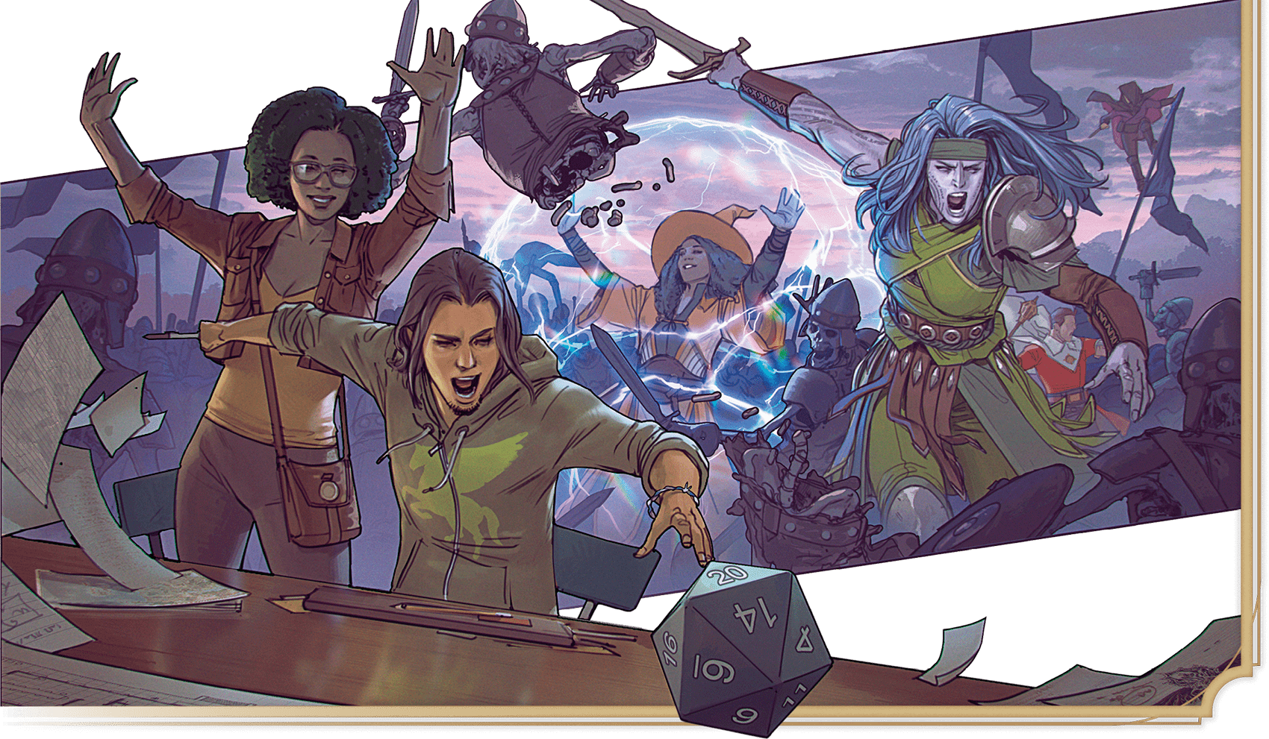](https://media.dndbeyond.com/compendium-images/phb/MKDHZ1nxSXDDLOw2/01-012.combat-example.png)